DEPARTMENT OF COMPUTERAPPLICATION
TKM COLLEGE OF ENGINEERING
KOLLAM – 691005


GROUP PROJECT WORK
Second Semester MCA 2020-2021

SUBMITTED BY:
ANANYA B
ANUSHREE
AMAL BHAS
RESHMA KRISHNAN
AMAL S
RASIKA V V
FATHIMA NOVRIN
SNEHA ROY

DEPARTMENT OF COMPUTER APPLICATION
TKM COLLEGE OF ENGINEERING
KOLLAM – 691005

Certificate

This is a bonafide project report of the work done by ANANYA B,AMAL BHAS,ANUSHREE,AMAL S,SNEHA ROY,RASIKA V V,FATHIMA NOVRIN,RESHMA KRISHNAN in the Second Semester towards the partial fulfillment of the degree of Master of Computer Applications during the academic year 2020-2021.

Staff Member in-charge Examiner

……………………….. ……………………

AIRLINE RESERVATION SYSTEM

INDEX

1.INTRODUCTION…………………………………………………………………….1
1.1 Abstract……………………………………………………………………………1
1.2 Existing System……………………………………………………………………2
1.3 Proposed System…………………………………………………………………...2
2. REQUIREMENTS ……………………………………………………........................3
2.1 Hardware Requirements…………………………………………………………....4
2.2 Software Requirements…………………………………………………………….4
3. MODULE DESCRIPTION………………………………………………………….24
4. DESIGN………………………………………………………………………………27
4.1 Use case Diagram ………………………………………………………………..28
4.2 Class Diagram ……………………………………………………………………30
4.3 Sequence Diagram ……………………………………………………………….31
4.4 Collaboration Diagram……………………………………………………………32
4.5 E-R Diagram ……………………………………………………………………..33
4.6 Data dictionary……………………………………………………………………34
5. CODING……………………………………………………………………………...37
6. TESTING……………………………………………………………………………..58
7. OUTPUT SCREENS………………………………………………….......................63
8. CONCLUSION………………………………………………………………………78
9. BIBLIOGRAPHY …………………………………………………………………..80

INTRODUCTION

ABSTRACT

Airline Reservation System contains the details about flight schedules and its fare tariffs, passenger reservations and ticket records. An airline’s inventory contains all flights with their available seats. In this “Airline Reservation System” main aim is to provide the online ticket & seat reservation of Flights and also give us the information about flight departures. This project mainly, we are going to concentrate on ticket booking function, this function will take the user inputs like their requirements (flight name, flight source & destination, Number of seats, Seat numbers), after entering all of his/her requirements in this application, it can check at backend & provide us the total information about flights. Reserved and booked seats should be mentioned so that no two passengers can have the same seat for the same journey

1. INTRODUCTION

  - Existing System :
In few countries if a person wants to book a flight ticket, he use to follow one of these things:
- Manually goes to the Airport and book his ticket.
- Downloading the ticket form as paper document, filling it manually and submitting it at Airport.
- Fill the Ticket form on system and get the print out as paper documents to submit it at Airport.
- Booking the Ticket at some particular registered ticket counters in online.
- Even above approaches make a ticket booking online, it was not completely done on online. Passenger may not have much freedom over this approach.
- Hence the Passenger may or may not be satisfied with this approach as it includes manual intervention like travelling to Airport for booking his ticket.

1.2 Proposed System:

The Proposed system ensures the complete freedom for users, where user at his own system can logon to this website and can book his ticket. Our proposed system allows only registered users to book the tickets, view timings and cancel their tickets.
In this Proposal the entire work is done on online and ticket with id is also provided for passengers as a print document.

REQUIREMENTS

2. REQUIREMENTS

2.1 Hard ware Specification

- Processor : Intel Core i3
- RAM : 4 GB (minimum)

  - Software Requirements

- Front end : Java Applet , Swing
- Back end : NoSQL Server (MongoDB)
- Operating System : Windows OS

FRONTEND
Java Applet
Applet is a special type of program that is embedded in the webpage to generate the dynamic content. It runs inside the browser and works at client side.
Advantage of Applet
There are many advantages of applet. They are as follows:
- It works at client side so less response time.
- Secured
- It can be executed by browsers running under many plateforms, including Linux, Windows, Mac Os etc.

Lifecycle of Java Applet
- Applet is initialized.
- Applet is started.
- Applet is painted.
- Applet is stopped.
- Applet is destroyed.

Lifecycle methods for Applet:
The java.applet.Applet class 4 life cycle methods and java.awt.Component class provides 1 life cycle methods for an applet.

java.applet.Applet class
For creating any applet java.applet.Applet class must be inherited. It provides 4 life cycle methods of applet.
- public void init(): is used to initialized the Applet. It is invoked only once.
- public void start(): is invoked after the init() method or browser is maximized. It is used to start the Applet.
- public void stop(): is used to stop the Applet. It is invoked when Applet is stop or browser is minimized.
- public void destroy(): is used to destroy the Applet. It is invoked only once.
EventHandling in Applet
As we perform event handling in AWT or Swing, we can perform it in applet also. Let's
see the simple example of event handling in applet that prints a message by click on the button.Java AWT (Abstract Window Toolkit) is an API to develop Graphical User Interface (GUI) or windows-based applications in Java.Java AWT components are platform-dependent i.e. components are displayed according to the view of operating system. AWT is heavy weight i.e. its components are using the resources of underlying operating system (OS).The java.awt package provides classes for AWT API such as TextField, Label, TextArea, RadioButton, CheckBox, Choice, List etc.

Why AWT is platform independent?
Java AWT calls the native platform calls the native platform (operating systems) subroutine for creating API components like TextField, ChechBox, button, etc.
For example, an AWT GUI with components like TextField, label and button will have different look and feel for the different platforms like Windows, MAC OS, and Unix. The reason for this is the platforms have different view for their native components and AWT directly calls the native subroutine that creates those components.
In simple words, an AWT application will look like a windows application in Windows OS whereas it will look like a Mac application in the MAC OS.
Components
All the elements like the button, text fields, scroll bars, etc. are called components. In Java AWT, there are classes for each component as shown in above diagram. In order to place every component in a particular position on a screen, we need to add them to a container.
Container
The Container is a component in AWT that can contain another components like buttons, textfields, labels etc. The classes that extends Container class are known as container such as Frame, Dialog and Panel.
Types of containers:
There are four types of containers in Java AWT:
- Window
- Panel
- Frame
- Dialog
Window
The window is the container that have no borders and menu bars. You must use frame, dialog or another window for creating a window. We need to create an instance of Window class to create this container.
Panel
The Panel is the container that doesn't contain title bar, border or menu bar. It is generic container for holding the components. It can have other components like button, text field etc. An instance of Panel class creates a container, in which we can add components.
Frame
The Frame is the container that contain title bar and border and can have menu bars. It can have other components like button, text field, scrollbar etc. Frame is most widely used container while developing an AWT application.

Java Swing tutorial is a part of Java Foundation Classes (JFC) that is used to create window-based applications. It is built on the top of AWT (Abstract Windowing Toolkit) API and entirely written in java.Unlike AWT, Java Swing provides platform-independent and lightweight components.The javax.swing package provides classes for java swing API such as JButton, JTextField, JTextArea, JRadioButton, JCheckbox, JMenu, JColorChooser etc.

Difference between AWT and Swing
There are many differences between java awt and swing that are given below.
No. | Java AWT | Java Swing
1) | AWT components are platform-dependent. | Java swing components are platform-independent.
2) | AWT components are heavyweight. | Swing components are lightweight.
3) | AWT doesn't support pluggable look and feel. | Swing supports pluggable look and feel.
4) | AWT provides less components than Swing. | Swing provides more powerful components such as tables, lists, scrollpanes, colorchooser, tabbedpane etc.
5) | AWT doesn't follows MVC(Model View Controller) where model represents data, view represents presentation and controller acts as an interface between model and view. | Swing follows MVC.
What is JFC
The Java Foundation Classes (JFC) are a set of GUI components which simplify the development of desktop applications.
Java Swing Examples
There are two ways to create a frame:

By creating the object of Frame class (association)
By extending Frame class (inheritance)
We can write the code of swing inside the main(), constructor or any other method.

BACKEND

MongoDB is an open-source document database and leading NoSQL database.MongoDB is written in C++. MongoDB concepts needed to create and deploy a highly scalable and performance-oriented database. MongoDB is a cross-platform, document oriented
database that provides, high performance, high availability, and easy scalability.
MongoDB works on concept of collection and document.
Database
Database is a physical container for collections. Each database gets its own set of files on the file system. A single MongoDB server typically has multiple databases.
Collection
Collection is a group of MongoDB documents. It is the equivalent of an RDBMS table. A collection exists within a single database. Collections do not enforce a schema. Documents within a collection can have different fields. Typically, all documents in a collection are of similar or related purpose.
Document
A document is a set of key-value pairs. Documents have dynamic schema. Dynamic schema means that documents in the same collection do not need to have the same set of fields or structure, and common fields in a collection's documents may hold different types of data.
The following table shows the relationship of RDBMS terminology with MongoDB.
RDBMS | MongoDB
Database | Database
Table | Collection
Tuple/Row | Document
Column | Field
Table Join | Embedded Documents
Primary Key | Primary Key (Default key _id provided by MongoDB itself)
Database Server and Client
mysqld/Oracle | mongod
mysql/sqlplus | mongo

Advantages of MongoDB over RDBMS
- Schema less − MongoDB is a document database in which one collection holds different documents. Number of fields, content and size of the document can differ from one document to another.
- Structure of a single object is clear.
- No complex joins.
- Deep query-ability. MongoDB supports dynamic queries on documents using a document-based query language that's nearly as powerful as SQL.
- Tuning.
- Ease of scale-out − MongoDB is easy to scale.
- Conversion/mapping of application objects to database objects not needed.
- Uses internal memory for storing the (windowed) working set, enabling faster access of data.
Why Use MongoDB?
- Document Oriented Storage − Data is stored in the form of JSON style documents.
- Index on any attribute
- Replication and high availability
- Auto-Sharding
- Rich queries
- Fast in-place updates
- Professional support by MongoDB

Where to Use MongoDB?
- Big Data
- Content Management and Delivery
- Mobile and Social Infrastructure
- User Data Management
- Data Hub
Data in MongoDB has a flexible schema.documents in the same collection. They do not need to have the same set of fields or structure Common fields in a collection’s documents may hold different types of data.

Data Model Design
MongoDB provides two types of data models: — Embedded data model and Normalized data model. Based on the requirement, you can use either of the models while preparing your document.

Embedded Data Model
In this model, you can have (embed) all the related data in a single document, it is also known as de-normalized data model.
Considerations while designing Schema in MongoDB
- Design your schema according to user requirements.
- Combine objects into one document if you will use them together. Otherwise separate them (but make sure there should not be need of joins).
- Duplicate the data (but limited) because disk space is cheap as compare to compute time.
- Do joins while write, not on read.
- Optimize your schema for most frequent use cases.
- Do complex aggregation in the schema.

Installation
Before you start using MongoDB in your Java programs, you need to make sure that you have MongoDB CLIENT and Java set up on the machine. You can check Java tutorial for Java installation on your machine. Now, let us check how to set up MongoDB CLIENT.You need to download the jar mongodb-driver-3.11.2.jar and its dependency mongodb-driver-core-3.11.2.jar. Make sure to download the latest release of these jar files.You need to include the downloaded jar files into your classpath.

Connect to Database
To connect database, you need to specify the database name, if the database doesn't exist then MongoDB creates it automatically.

Create a Collection
To create a collection, createCollection() method of com.mongodb.client.MongoDatabase class is used.

Getting/Selecting a Collection
To get/select a collection from the database, getCollection() method of com.mongodb.client.MongoDatabase class is used.

Insert a Document
To insert a document into MongoDB, insert() method of com.mongodb.client.MongoCollection class is used.

Retrieve All Documents
To select all documents from the collection, find() method of com.mongodb.client.MongoCollection class is used. This method returns a cursor, so you need to iterate this cursor.

DATABASE

NoSQL SERVER :
A database management, or DBMS, gives the user access to their data and helps them transform the data into information. Such database management systems include dBase, paradox, IMS, SQL Server and SQL Server. These systems allow users to create, update and extract information from their database.A database is a structured collection of data. Data refers to the characteristics of people, things and events.

NoSQL databases (aka "not only SQL") are non-tabular databases and store data differently than relational tables. NoSQL databases come in a variety of types based on their data model. The main types are document, key-value, wide-column, and graph. They provide flexible schemas and scale easily with large amounts of data and high user loads.
NoSQL database features
Each NoSQL database has its own unique features. At a high level, many NoSQL databases have the following features:
- Flexible schemas
- Horizontal scaling
- Fast queries due to the data model
- Ease of use for developers
Types of NoSQL databases
Over time, four major types of NoSQL databases emerged: document databases, key-value databases, wide-column stores, and graph databasesDocument databases store data in documents similar to JSON (JavaScript Object Notation) objects. Each document contains pairs of fields and values. The values can typically be a variety of types including things like strings, numbers, booleans, arrays, or objects.Key-value databases are a simpler type of database where each item contains keys and values.Wide-column stores store data in tables, rows, and dynamic columns.Graph databases store data in nodes and edges.

MODULE DESCRIPTION

MODULE DESCRIPTION

The list of modules incorporated with “AIRLINE RESERVATION SYSTEM” are

- Registration module

- Administrative module

- Passenger module

1. Registration module

In registration module first we ask passenger to give his details.After registering with us the passenger can logon to his/her own account and can view all flight details such as Timings, Prices,Availability of seats and can book the ticket with unique ticket id.Once Passenger registered with us can book any number of tickets.

2. Administrative module

Administrative module is provided for the sake of administrators to manage the site and update the content at regular intervals, The major operations included in this module are:

- Create and maintain airline schedule, fare and timings of the Flight.
- View the passenger list.
- View the available seats in the flights.
- Cancel the tickets.
- Updating the flight schedule and timings and fare.

3. Passenger module

This module is meant for passengers, where a user logging into his/her owns account will view this panel. The major operations included in this module were

- View all airline schedules, timings, fare details and seats availability.
- Book for the tickets.
- View and cancelling of the ticket.
- Send feedback.

DESIGN

Class Diagram 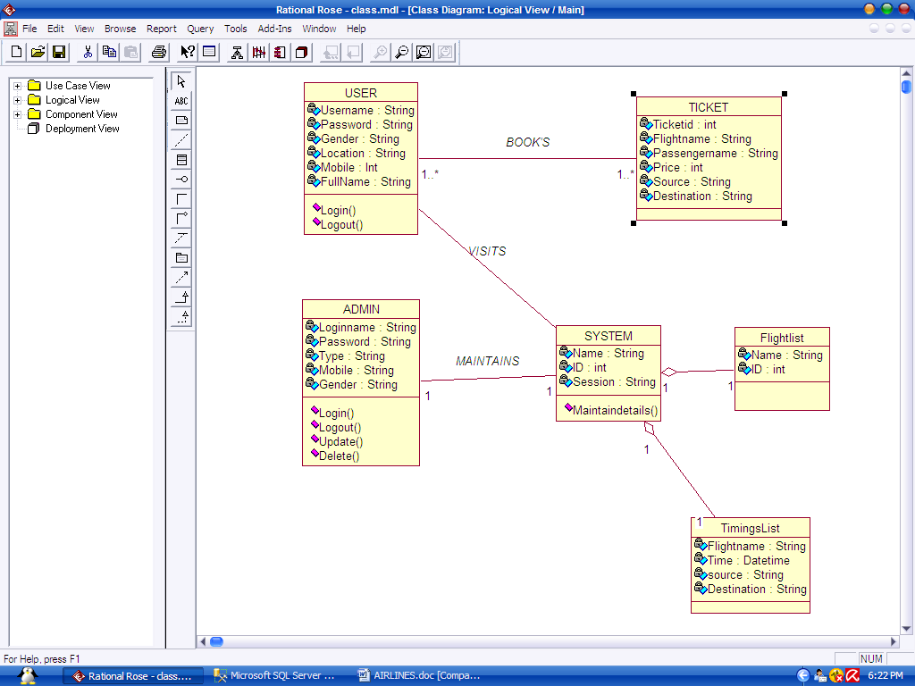

E-R diagram
TICKET BOOKING
Ticket id no
Passengername
DestinationStationon
No.passengers
SourceStation
FligthName
LOGIN
Loginnamee
Password
Name
Gender
Mobile
Location
Type
SCHEDULING
Flightname
Time
Sourcestation
ID
Destination Station
FEEDBACK
Name
Email
Subject
Seats
Books
Depends
Gives

TABLE DESIGN

ATTRIBUTE NAME | DATATYPE | CONSTRAINTS | SAMPLE VALUES
ID | Int | Primary key | 1
Name | Varchar(50) | Not null | Ram
Email | Varchar(50) | Not null | Ram11@yahoo.com
Subject | Varchar(50) | Not null | Password
Message | Varchar(MAX) | Null | Some text message here

SCHEDULING TABLE

ATTRIBUTE NAME | DATATYPE | CONSTRAINTS | SAMPLE VALUE
Flightname | Varchar(50) | Primary key | Ram
Time | Datetime | Not null | 27/06/2020 6:55:00 AM
Sourcestation | Varchar(50) | Not null | HYDERABAD
Destinationstation | Varchar(50) | Not null | NEW DELHI
Seats | int | Not null | 120
Price | int | Not null | 1200

TICKETBOOKING TABLE

ATTRIBUTE NAME | DATATYPE | CONSTRAINTS | SAMPLE VALUES
Passengername | Varchar(50) | Foreign key | Sam
Flightname | Varchar(50) | Foreign key | Kingfisher
Sourcestation | Varchar(50) | Not null | HYDERABAD
Destinationstation | Varchar(50) | Not null | DELHI
Ticketno | int | Primary key | 104
Numberof paasengers | Int | Not null | 3

REGISTRATION TABLE

ATTRIBUTE NAME | DATATYPE | CONSTRAINTS | SAMPLEVALUES
Username | Varchar2(20) | Primary key | Sam
Password | Varchar2(20) | check | Sam1230
First name | Number(10) | Not null | Sam Roy
Gender | Varchar2(20) | Not null | Male
Location | Number (20) | Not null | INDIA
Phno | Number(10) | Not null | 9177761547

CODING

Welcome3.java
package source;
import javax.swing.*;
import my.Package.Client;
import java.awt.*;
import java.awt.event.*;
import java.awt.event.ActionListener;
import source.Register;
import source.login;
class Welcome3 extends JFrame
{
JButton b1,b2;
JLabel l1,l3;

public Welcome3()
{
setTitle("Welcome To Airline Ticket Booking...");
setSize(1000,1000);
setLocationRelativeTo(null);
setDefaultCloseOperation(EXIT_ON_CLOSE);
setVisible(true);

setLayout(new BorderLayout());
JLabel background=new JLabel(new ImageIcon("H:\\Sem-2\\Mini-Project\\flight_2.jpg"));
add(background);

background.setLayout(new FlowLayout());
JLabel l2=new JLabel();
l2.setText(" AERO TRAVELS ");
l2.setFont(new Font("Verdana", Font.PLAIN, 90));
l2.setLocation(150, 150);
l1=new JLabel("");
b1=new JButton("Login");
b2=new JButton("Register");
b2.setBounds(10,200,195,130);

l2.setForeground(Color.WHITE);
background.add(l1);
background.add(b1);
background.add(b2);
System.out.println("\n\n");
background.add(l2);
setSize(400,400);
setSize(400,400);

b2.addActionListener(new ActionListener() {
@Override
public void actionPerformed(ActionEvent e) {

System.out.println("clicked Register");
MyFrame myFrame=new MyFrame();
myFrame.setVisible(true);

}
});
b1.addActionListener(new ActionListener() {
@Override
public void actionPerformed(ActionEvent e) {

System.out.println("clicked Login");
Client c=new Client();
c.setVisible(true);

}
});
}
//private void JButtonActionPerformed(java.awt.event.ActionEvent evt) {
// MyFrame f = new MyFrame();
// f.setVisible(true);

//}

// class MyLogin extends Welcome{
// public JFrame f = new JFrame("Login");
// public JButton bok = new JButton("OK");
//
// public MyLogin() {
//
// f.setDefaultCloseOperation(JFrame.HIDE_ON_CLOSE);
// f.getContentPane().add(bok);
//
// bok.addActionListener(new ActionListener() {
// public void actionPerformed(ActionEvent ae) {
// f.dispose();
// new MyFrame();
// }
// });
// f.setSize(100,100);
// f.setVisible(true);
// }
//
// }

public static void main(String args[])
{
new Welcome3();
}
}

Register.java
package source;

import javax.swing.*;
import java.awt.*;
import java.awt.event.*;

class MyFrame
extends JFrame
implements ActionListener {

// Components of the Form
private Container c;
private JLabel title;
private JLabel name;
private JTextField tname;
private JLabel mno;
private JTextField tmno;
private JLabel gender;
private JRadioButton male;
private JRadioButton female;
private ButtonGroup gengp;
private JLabel dob;
private JComboBox date;
private JComboBox month;
private JComboBox year;
private JLabel add;
private JTextArea tadd;
private JCheckBox term;
private JButton sub;
private JButton reset;
private JTextArea tout;
private JLabel res;
private JTextArea resadd;

private String dates[]
= { "1", "2", "3", "4", "5",
"6", "7", "8", "9", "10",
"11", "12", "13", "14", "15",
"16", "17", "18", "19", "20",
"21", "22", "23", "24", "25",
"26", "27", "28", "29", "30",
"31" };
private String months[]
= { "Jan", "feb", "Mar", "Apr",
"May", "Jun", "July", "Aug",
"Sup", "Oct", "Nov", "Dec" };
private String years[]
= { "1995", "1996", "1997", "1998",
"1999", "2000", "2001", "2002",
"2003", "2004", "2005", "2006",
"2007", "2008", "2009", "2010",
"2011", "2012", "2013", "2014",
"2015", "2016", "2017", "2018",
"2019" };

// constructor, to initialize the components
// with default values.
public MyFrame()
{
setTitle("Registration Form");
setBounds(300, 90, 900, 600);
setDefaultCloseOperation(EXIT_ON_CLOSE);
setResizable(false);

c = getContentPane();
c.setLayout(null);

title = new JLabel("Registration Form");
title.setFont(new Font("Arial", Font.PLAIN, 30));
title.setSize(300, 30);
title.setLocation(300, 30);
c.add(title);

name = new JLabel("Name");
name.setFont(new Font("Arial", Font.PLAIN, 20));
name.setSize(100, 20);
name.setLocation(100, 100);
c.add(name);

tname = new JTextField();
tname.setFont(new Font("Arial", Font.PLAIN, 15));
tname.setSize(190, 20);
tname.setLocation(200, 100);
c.add(tname);

mno = new JLabel("Mobile");
mno.setFont(new Font("Arial", Font.PLAIN, 20));
mno.setSize(100, 20);
mno.setLocation(100, 150);
c.add(mno);

tmno = new JTextField();
tmno.setFont(new Font("Arial", Font.PLAIN, 15));
tmno.setSize(150, 20);
tmno.setLocation(200, 150);
c.add(tmno);

gender = new JLabel("Gender");
gender.setFont(new Font("Arial", Font.PLAIN, 20));
gender.setSize(100, 20);
gender.setLocation(100, 200);
c.add(gender);

male = new JRadioButton("Male");
male.setFont(new Font("Arial", Font.PLAIN, 15));
male.setSelected(true);
male.setSize(75, 20);
male.setLocation(200, 200);
c.add(male);

female = new JRadioButton("Female");
female.setFont(new Font("Arial", Font.PLAIN, 15));
female.setSelected(false);
female.setSize(80, 20);
female.setLocation(275, 200);
c.add(female);

gengp = new ButtonGroup();
gengp.add(male);
gengp.add(female);

dob = new JLabel("DOB");
dob.setFont(new Font("Arial", Font.PLAIN, 20));
dob.setSize(100, 20);
dob.setLocation(100, 250);
c.add(dob);

date = new JComboBox(dates);
date.setFont(new Font("Arial", Font.PLAIN, 15));
date.setSize(50, 20);
date.setLocation(200, 250);
c.add(date);

month = new JComboBox(months);
month.setFont(new Font("Arial", Font.PLAIN, 15));
month.setSize(60, 20);
month.setLocation(250, 250);
c.add(month);

year = new JComboBox(years);
year.setFont(new Font("Arial", Font.PLAIN, 15));
year.setSize(60, 20);
year.setLocation(320, 250);
c.add(year);

add = new JLabel("Address");
add.setFont(new Font("Arial", Font.PLAIN, 20));
add.setSize(100, 20);
add.setLocation(100, 300);
c.add(add);

tadd = new JTextArea();
tadd.setFont(new Font("Arial", Font.PLAIN, 15));
tadd.setSize(200, 75);
tadd.setLocation(200, 300);
tadd.setLineWrap(true);
c.add(tadd);

term = new JCheckBox("Accept Terms And Conditions.");
term.setFont(new Font("Arial", Font.PLAIN, 15));
term.setSize(250, 20);
term.setLocation(150, 400);
c.add(term);

sub = new JButton("Submit");
sub.setFont(new Font("Arial", Font.PLAIN, 15));
sub.setSize(100, 20);
sub.setLocation(150, 450);
sub.addActionListener(this);
c.add(sub);

reset = new JButton("Reset");
reset.setFont(new Font("Arial", Font.PLAIN, 15));
reset.setSize(100, 20);
reset.setLocation(270, 450);
reset.addActionListener(this);
c.add(reset);

tout = new JTextArea();
tout.setFont(new Font("Arial", Font.PLAIN, 15));
tout.setSize(300, 400);
tout.setLocation(500, 100);
tout.setLineWrap(true);
tout.setEditable(false);
c.add(tout);

res = new JLabel("");
res.setFont(new Font("Arial", Font.PLAIN, 20));
res.setSize(500, 25);
res.setLocation(100, 500);
c.add(res);

resadd = new JTextArea();
resadd.setFont(new Font("Arial", Font.PLAIN, 15));
resadd.setSize(200, 75);
resadd.setLocation(580, 175);
resadd.setLineWrap(true);
c.add(resadd);

setVisible(true);
}

// method actionPerformed()
// to get the action performed
// by the user and act accordingly
public void actionPerformed(ActionEvent e)
{
if (e.getSource() == sub) {
if (term.isSelected()) {
String data1;
String data
= "Name : "
+ tname.getText() + "\n"
+ "Mobile : "
+ tmno.getText() + "\n";
if (male.isSelected())
data1 = "Gender : Male"
+ "\n";
else
data1 = "Gender : Female"
+ "\n";
String data2
= "DOB : "
+ (String)date.getSelectedItem()
+ "/" + (String)month.getSelectedItem()
+ "/" + (String)year.getSelectedItem()
+ "\n";

String data3 = "Address : " + tadd.getText();
tout.setText(data + data1 + data2 + data3);
tout.setEditable(false);
res.setText("Registration Successfully..");
}
else {
tout.setText("");
resadd.setText("");
res.setText("Please accept the"
+ " terms & conditions..");
}
}

else if (e.getSource() == reset) {
String def = "";
tname.setText(def);
tadd.setText(def);
tmno.setText(def);
res.setText(def);
tout.setText(def);
term.setSelected(false);
date.setSelectedIndex(0);
month.setSelectedIndex(0);
year.setSelectedIndex(0);
resadd.setText(def);
}
}
}

// Driver Code
class Register
{

public static void main(String[] args) throws Exception
{
MyFrame f = new MyFrame();
}
}

Client.java

package my.Package;

import java.awt.event.ActionEvent;
import java.awt.event.ActionListener;
import javax.swing.table.DefaultTableModel;
import javax.swing.JPopupMenu;
import javax.swing.ImageIcon;
import javax.swing.JLabel;
import javax.swing.JMenuItem;

import java.awt.Color;
import java.awt.Graphics;
import java.awt.Image;
import java.awt.Toolkit;
import javax.swing.JFrame;

public class Client extends javax.swing.JFrame {

/**
* Creates new form login
*/

public Client() {
initComponents();
}

@SuppressWarnings("unchecked")

private void initComponents() {
JFrame frame = new JFrame();
frame.setIconImage(Toolkit.getDefaultToolkit().getImage("C:\\Users\\HP\\Downloads\\"));
buttonGroup1 = new javax.swing.ButtonGroup();
loginScreen = new javax.swing.JPanel();
jLabel1 = new javax.swing.JLabel();
jLabel2 = new javax.swing.JLabel();
username = new javax.swing.JTextField();
password = new javax.swing.JPasswordField();
jButton1 = new javax.swing.JButton();
jButton2 = new javax.swing.JButton();
status = new javax.swing.JLabel();
adminPanel = new javax.swing.JTabbedPane();
search = new javax.swing.JPanel();
jLabel3 = new javax.swing.JLabel();
departure = new javax.swing.JTextField();
jLabel4 = new javax.swing.JLabel();
arrival = new javax.swing.JTextField();
jButton8 = new javax.swing.JButton();
jSeparator1 = new javax.swing.JSeparator();
dispData = new javax.swing.JPanel();
jScrollPane1 = new javax.swing.JScrollPane();
searchData = new javax.swing.JTable();
addRemoveFlight = new javax.swing.JPanel();
jLabel5 = new javax.swing.JLabel();
dept = new javax.swing.JTextField();
jLabel6 = new javax.swing.JLabel();
arr = new javax.swing.JTextField();
jButton9 = new javax.swing.JButton();
stat = new javax.swing.JLabel();
jLabel7 = new javax.swing.JLabel();
idInput = new javax.swing.JTextField();
jLabel8 = new javax.swing.JLabel();
hourInput = new javax.swing.JComboBox();
minInput = new javax.swing.JComboBox();
jLabel9 = new javax.swing.JLabel();
seatInput = new javax.swing.JTextField();
removeFlight = new javax.swing.JPanel();
jLabel13 = new javax.swing.JLabel();
departure1 = new javax.swing.JTextField();
jLabel14 = new javax.swing.JLabel();
arrival1 = new javax.swing.JTextField();
jButton11 = new javax.swing.JButton();
jButton10 = new javax.swing.JButton();
idText = new javax.swing.JTextField();
jLabel10 = new javax.swing.JLabel();
jScrollPane2 = new javax.swing.JScrollPane();
searchData2 = new javax.swing.JTable();
error = new javax.swing.JLabel();
bookSeat = new javax.swing.JPanel();
jLabel11 = new javax.swing.JLabel();
bDept = new javax.swing.JTextField();
jLabel12 = new javax.swing.JLabel();
bArr = new javax.swing.JTextField();
jLabel15 = new javax.swing.JLabel();
bId = new javax.swing.JTextField();
jLabel16 = new javax.swing.JLabel();
name = new javax.swing.JTextField();
jLabel17 = new javax.swing.JLabel();
age = new javax.swing.JTextField();
jLabel18 = new javax.swing.JLabel();
phone = new javax.swing.JTextField();
jLabel19 = new javax.swing.JLabel();
male = new javax.swing.JRadioButton();
female = new javax.swing.JRadioButton();
jButton12 = new javax.swing.JButton();
bStatus = new javax.swing.JLabel();
checkReservation = new javax.swing.JPanel();
jLabel20 = new javax.swing.JLabel();
cDept = new javax.swing.JTextField();
jLabel21 = new javax.swing.JLabel();
cArr = new javax.swing.JTextField();
jLabel22 = new javax.swing.JLabel();
cId = new javax.swing.JTextField();
jScrollPane3 = new javax.swing.JScrollPane();
reservationData = new javax.swing.JTable();
jButton13 = new javax.swing.JButton();
cStatus = new javax.swing.JLabel();

setDefaultCloseOperation(javax.swing.WindowConstants.EXIT_ON_CLOSE);
setTitle("Airline Reservation System");
setPreferredSize(new java.awt.Dimension(600, 500));

loginScreen.setBorder(javax.swing.BorderFactory.createTitledBorder("Log In"));
loginScreen.setPreferredSize(new java.awt.Dimension(600, 450));

jLabel1.setText("User Name");

jLabel2.setText("Password");

username.addActionListener(new java.awt.event.ActionListener() {
public void actionPerformed(java.awt.event.ActionEvent evt) {
usernameActionPerformed(evt);
}
});

jButton1.setText("Log in as Passenger");
jButton1.addActionListener(new java.awt.event.ActionListener() {
public void actionPerformed(java.awt.event.ActionEvent evt) {
jButton1ActionPerformed(evt);
}
});

jButton2.setText("Log in as Admin");
jButton2.addActionListener(new java.awt.event.ActionListener() {
public void actionPerformed(java.awt.event.ActionEvent evt) {
jButton2ActionPerformed(evt);
}
});

javax.swing.GroupLayout loginScreenLayout = new javax.swing.GroupLayout(loginScreen);
loginScreen.setLayout(loginScreenLayout);
loginScreenLayout.setHorizontalGroup(
loginScreenLayout.createParallelGroup(javax.swing.GroupLayout.Alignment.LEADING)
.addGroup(loginScreenLayout.createSequentialGroup()
.addGap(59, 59, 59)
.addGroup(loginScreenLayout.createParallelGroup(javax.swing.GroupLayout.Alignment.LEADING, false)
.addGroup(loginScreenLayout.createSequentialGroup()
.addGroup(loginScreenLayout.createParallelGroup(javax.swing.GroupLayout.Alignment.TRAILING)
.addComponent(jLabel2)
.addComponent(jLabel1))
.addGap(32, 32, 32)
.addGroup(loginScreenLayout.createParallelGroup(javax.swing.GroupLayout.Alignment.LEADING, false)
.addComponent(password, javax.swing.GroupLayout.DEFAULT_SIZE, 137, Short.MAX_VALUE)
.addComponent(username)))
.addGroup(loginScreenLayout.createSequentialGroup()
.addGap(7, 7, 7)
.addGroup(loginScreenLayout.createParallelGroup(javax.swing.GroupLayout.Alignment.LEADING)
.addComponent(status, javax.swing.GroupLayout.DEFAULT_SIZE, javax.swing.GroupLayout.DEFAULT_SIZE, Short.MAX_VALUE)
.addGroup(loginScreenLayout.createSequentialGroup()
.addComponent(jButton1)
.addGap(18, 18, 18)
.addComponent(jButton2, javax.swing.GroupLayout.DEFAULT_SIZE, 106, Short.MAX_VALUE)))))
.addContainerGap(290, Short.MAX_VALUE))
);
loginScreenLayout.setVerticalGroup(
loginScreenLayout.createParallelGroup(javax.swing.GroupLayout.Alignment.LEADING)
.addGroup(loginScreenLayout.createSequentialGroup()
.addGap(45, 45, 45)
.addGroup(loginScreenLayout.createParallelGroup(javax.swing.GroupLayout.Alignment.BASELINE)
.addComponent(jLabel1)
.addComponent(username, javax.swing.GroupLayout.PREFERRED_SIZE, javax.swing.GroupLayout.DEFAULT_SIZE, javax.swing.GroupLayout.PREFERRED_SIZE))
.addGap(18, 18, 18)
.addGroup(loginScreenLayout.createParallelGroup(javax.swing.GroupLayout.Alignment.BASELINE)
.addComponent(jLabel2)
.addComponent(password, javax.swing.GroupLayout.PREFERRED_SIZE, javax.swing.GroupLayout.DEFAULT_SIZE, javax.swing.GroupLayout.PREFERRED_SIZE))
.addGap(27, 27, 27)
.addGroup(loginScreenLayout.createParallelGroup(javax.swing.GroupLayout.Alignment.BASELINE)
.addComponent(jButton2)
.addComponent(jButton1))
.addPreferredGap(javax.swing.LayoutStyle.ComponentPlacement.UNRELATED)
.addComponent(status, javax.swing.GroupLayout.PREFERRED_SIZE, 30, javax.swing.GroupLayout.PREFERRED_SIZE)
.addContainerGap(246, Short.MAX_VALUE))
);

adminPanel.setPreferredSize(new java.awt.Dimension(600, 500));

search.setPreferredSize(new java.awt.Dimension(600, 500));

jLabel3.setText("Departure");

jLabel4.setText("Arrival");

jButton8.setText("Search");
jButton8.addActionListener(new java.awt.event.ActionListener() {
public void actionPerformed(java.awt.event.ActionEvent evt) {
jButton8ActionPerformed(evt);
}
});

javax.swing.GroupLayout dispDataLayout = new javax.swing.GroupLayout(dispData);
dispData.setLayout(dispDataLayout);
dispDataLayout.setHorizontalGroup(
dispDataLayout.createParallelGroup(javax.swing.GroupLayout.Alignment.LEADING)
.addGap(0, 0, Short.MAX_VALUE)
);
dispDataLayout.setVerticalGroup(
dispDataLayout.createParallelGroup(javax.swing.GroupLayout.Alignment.LEADING)
.addGap(0, 0, Short.MAX_VALUE)
);

searchData.setModel(new javax.swing.table.DefaultTableModel(
new Object [][] {

},
new String [] {
"Flight", "From", "Time", "To", "Time"
}
) {
/**
*
*/
private static final long serialVersionUID = 1L;
Class[] types = new Class [] {
java.lang.String.class, java.lang.String.class, java.lang.String.class, java.lang.String.class, java.lang.String.class
};
boolean[] canEdit = new boolean [] {
false, false, false, false, false
};

public Class getColumnClass(int columnIndex) {
return types [columnIndex];
}

public boolean isCellEditable(int rowIndex, int columnIndex) {
return canEdit [columnIndex];
}
});
searchData.getTableHeader().setReorderingAllowed(false);
searchData.addMouseListener(new java.awt.event.MouseAdapter() {
public void mouseClicked(java.awt.event.MouseEvent evt) {
searchDataMouseClicked(evt);
}
});
jScrollPane1.setViewportView(searchData);

javax.swing.GroupLayout searchLayout = new javax.swing.GroupLayout(search);
search.setLayout(searchLayout);
searchLayout.setHorizontalGroup(
searchLayout.createParallelGroup(javax.swing.GroupLayout.Alignment.LEADING)
.addComponent(jSeparator1)
.addGroup(searchLayout.createSequentialGroup()
.addContainerGap()
.addGroup(searchLayout.createParallelGroup(javax.swing.GroupLayout.Alignment.LEADING)
.addGroup(searchLayout.createSequentialGroup()
.addComponent(jLabel3, javax.swing.GroupLayout.PREFERRED_SIZE, 79, javax.swing.GroupLayout.PREFERRED_SIZE)
.addPreferredGap(javax.swing.LayoutStyle.ComponentPlacement.RELATED)
.addComponent(departure, javax.swing.GroupLayout.PREFERRED_SIZE, 127, javax.swing.GroupLayout.PREFERRED_SIZE)
.addPreferredGap(javax.swing.LayoutStyle.ComponentPlacement.RELATED)
.addComponent(jLabel4, javax.swing.GroupLayout.PREFERRED_SIZE, 79, javax.swing.GroupLayout.PREFERRED_SIZE)
.addPreferredGap(javax.swing.LayoutStyle.ComponentPlacement.RELATED)
.addComponent(arrival, javax.swing.GroupLayout.PREFERRED_SIZE, 127, javax.swing.GroupLayout.PREFERRED_SIZE)
.addPreferredGap(javax.swing.LayoutStyle.ComponentPlacement.UNRELATED)
.addComponent(jButton8, javax.swing.GroupLayout.DEFAULT_SIZE, 94, Short.MAX_VALUE)
.addGap(26, 26, 26))
.addGroup(javax.swing.GroupLayout.Alignment.TRAILING, searchLayout.createSequentialGroup()
.addComponent(dispData, javax.swing.GroupLayout.DEFAULT_SIZE, javax.swing.GroupLayout.DEFAULT_SIZE, Short.MAX_VALUE)
.addContainerGap())
.addGroup(searchLayout.createSequentialGroup()
.addComponent(jScrollPane1, javax.swing.GroupLayout.PREFERRED_SIZE, 548, javax.swing.GroupLayout.PREFERRED_SIZE)
.addContainerGap(javax.swing.GroupLayout.DEFAULT_SIZE, Short.MAX_VALUE))))
);
searchLayout.setVerticalGroup(
searchLayout.createParallelGroup(javax.swing.GroupLayout.Alignment.LEADING)
.addGroup(searchLayout.createSequentialGroup()
.addGap(23, 23, 23)
.addGroup(searchLayout.createParallelGroup(javax.swing.GroupLayout.Alignment.BASELINE)
.addComponent(jLabel3, javax.swing.GroupLayout.PREFERRED_SIZE, 31, javax.swing.GroupLayout.PREFERRED_SIZE)
.addComponent(departure, javax.swing.GroupLayout.PREFERRED_SIZE, javax.swing.GroupLayout.DEFAULT_SIZE, javax.swing.GroupLayout.PREFERRED_SIZE)
.addComponent(jLabel4, javax.swing.GroupLayout.PREFERRED_SIZE, 31, javax.swing.GroupLayout.PREFERRED_SIZE)
.addComponent(arrival, javax.swing.GroupLayout.PREFERRED_SIZE, javax.swing.GroupLayout.DEFAULT_SIZE, javax.swing.GroupLayout.PREFERRED_SIZE)
.addComponent(jButton8))
.addPreferredGap(javax.swing.LayoutStyle.ComponentPlacement.UNRELATED)
.addComponent(jSeparator1, javax.swing.GroupLayout.PREFERRED_SIZE, 16, javax.swing.GroupLayout.PREFERRED_SIZE)
.addPreferredGap(javax.swing.LayoutStyle.ComponentPlacement.RELATED)
.addComponent(jScrollPane1, javax.swing.GroupLayout.PREFERRED_SIZE, 214, javax.swing.GroupLayout.PREFERRED_SIZE)
.addGap(87, 87, 87)
.addComponent(dispData, javax.swing.GroupLayout.DEFAULT_SIZE, javax.swing.GroupLayout.DEFAULT_SIZE, Short.MAX_VALUE)
.addContainerGap())
);

adminPanel.addTab("Search For a Flight", search);

addRemoveFlight.setPreferredSize(new java.awt.Dimension(600, 500));

jLabel5.setText("Departure");

jLabel6.setText("Arrival");

arr.addActionListener(new java.awt.event.ActionListener() {
public void actionPerformed(java.awt.event.ActionEvent evt) {
arrActionPerformed(evt);
}
});

jButton9.setText("Add Flight");
jButton9.addActionListener(new java.awt.event.ActionListener() {
public void actionPerformed(java.awt.event.ActionEvent evt) {
jButton9ActionPerformed(evt);
}
});

jLabel7.setText("ID");

jLabel8.setText("Departure Time");

hourInput.setModel(new javax.swing.DefaultComboBoxModel(new String[] { "01", "02", "03", "04", "05", "06", "07", "08", "09", "10", "11", "12", "13", "14", "15", "16", "17", "18", "19", "20", "21", "22", "23", "24" }));

minInput.setModel(new javax.swing.DefaultComboBoxModel(new String[] { "00", "01", "02", "03", "04", "05", "06", "07", "08", "09", "10", "11", "12", "13", "14", "15", "16", "17", "18", "19", "20", "21", "22", "23", "24", "25", "26", "27", "28", "29", "30", "31", "32", "33", "34", "35", "36", "37", "38", "39", "40", "41", "42", "43", "44", "45", "46", "47", "48", "49", "50", "51", "52", "53", "54", "55", "56", "57", "58", "59", "60" }));
minInput.addActionListener(new java.awt.event.ActionListener() {
public void actionPerformed(java.awt.event.ActionEvent evt) {
minInputActionPerformed(evt);
}
});

jLabel9.setText("Seats");

seatInput.setCursor(new java.awt.Cursor(java.awt.Cursor.TEXT_CURSOR));

javax.swing.GroupLayout addRemoveFlightLayout = new javax.swing.GroupLayout(addRemoveFlight);
addRemoveFlight.setLayout(addRemoveFlightLayout);
addRemoveFlightLayout.setHorizontalGroup(
addRemoveFlightLayout.createParallelGroup(javax.swing.GroupLayout.Alignment.LEADING)
.addGroup(addRemoveFlightLayout.createSequentialGroup()
.addGap(0, 124, Short.MAX_VALUE)
.addGroup(addRemoveFlightLayout.createParallelGroup(javax.swing.GroupLayout.Alignment.TRAILING)
.addComponent(jButton9)
.addGroup(addRemoveFlightLayout.createSequentialGroup()
.addGroup(addRemoveFlightLayout.createParallelGroup(javax.swing.GroupLayout.Alignment.TRAILING)
.addComponent(jLabel8)
.addComponent(jLabel5)
.addComponent(jLabel6)
.addComponent(jLabel7)
.addComponent(jLabel9))
.addGap(67, 67, 67)
.addGroup(addRemoveFlightLayout.createParallelGroup(javax.swing.GroupLayout.Alignment.LEADING, false)
.addComponent(arr)
.addComponent(dept)
.addComponent(idInput)
.addGroup(addRemoveFlightLayout.createSequentialGroup()
.addComponent(hourInput, javax.swing.GroupLayout.PREFERRED_SIZE, 74, javax.swing.GroupLayout.PREFERRED_SIZE)
.addPreferredGap(javax.swing.LayoutStyle.ComponentPlacement.RELATED, 33, Short.MAX_VALUE)
.addComponent(minInput, javax.swing.GroupLayout.PREFERRED_SIZE, 68, javax.swing.GroupLayout.PREFERRED_SIZE))
.addComponent(seatInput))))
.addGap(129, 129, 129))
.addGroup(addRemoveFlightLayout.createSequentialGroup()
.addGap(189, 189, 189)
.addComponent(stat, javax.swing.GroupLayout.PREFERRED_SIZE, 175, javax.swing.GroupLayout.PREFERRED_SIZE)
.addContainerGap(javax.swing.GroupLayout.DEFAULT_SIZE, Short.MAX_VALUE))
);
addRemoveFlightLayout.setVerticalGroup(
addRemoveFlightLayout.createParallelGroup(javax.swing.GroupLayout.Alignment.LEADING)
.addGroup(addRemoveFlightLayout.createSequentialGroup()
.addGap(42, 42, 42)
.addGroup(addRemoveFlightLayout.createParallelGroup(javax.swing.GroupLayout.Alignment.BASELINE)
.addComponent(dept, javax.swing.GroupLayout.PREFERRED_SIZE, javax.swing.GroupLayout.DEFAULT_SIZE, javax.swing.GroupLayout.PREFERRED_SIZE)
.addComponent(jLabel5))
.addGap(18, 18, 18)
.addGroup(addRemoveFlightLayout.createParallelGroup(javax.swing.GroupLayout.Alignment.BASELINE)
.addComponent(arr, javax.swing.GroupLayout.PREFERRED_SIZE, javax.swing.GroupLayout.DEFAULT_SIZE, javax.swing.GroupLayout.PREFERRED_SIZE)
.addComponent(jLabel6))
.addGap(18, 18, 18)
.addGroup(addRemoveFlightLayout.createParallelGroup(javax.swing.GroupLayout.Alignment.BASELINE)
.addComponent(idInput, javax.swing.GroupLayout.PREFERRED_SIZE, javax.swing.GroupLayout.DEFAULT_SIZE, javax.swing.GroupLayout.PREFERRED_SIZE)
.addComponent(jLabel7))
.addGap(17, 17, 17)
.addGroup(addRemoveFlightLayout.createParallelGroup(javax.swing.GroupLayout.Alignment.BASELINE)
.addComponent(jLabel8)
.addComponent(hourInput, javax.swing.GroupLayout.PREFERRED_SIZE, javax.swing.GroupLayout.DEFAULT_SIZE, javax.swing.GroupLayout.PREFERRED_SIZE)
.addComponent(minInput, javax.swing.GroupLayout.PREFERRED_SIZE, javax.swing.GroupLayout.DEFAULT_SIZE, javax.swing.GroupLayout.PREFERRED_SIZE))
.addGap(18, 18, 18)
.addGroup(addRemoveFlightLayout.createParallelGroup(javax.swing.GroupLayout.Alignment.BASELINE)
.addComponent(jLabel9)
.addComponent(seatInput, javax.swing.GroupLayout.PREFERRED_SIZE, javax.swing.GroupLayout.DEFAULT_SIZE, javax.swing.GroupLayout.PREFERRED_SIZE))
.addGap(26, 26, 26)
.addComponent(jButton9)
.addPreferredGap(javax.swing.LayoutStyle.ComponentPlacement.RELATED, javax.swing.GroupLayout.DEFAULT_SIZE, Short.MAX_VALUE)
.addComponent(stat, javax.swing.GroupLayout.PREFERRED_SIZE, 20, javax.swing.GroupLayout.PREFERRED_SIZE)
.addGap(28, 28, 28))
);

adminPanel.addTab("Add Flights", addRemoveFlight);

removeFlight.setPreferredSize(new java.awt.Dimension(600, 500));

jLabel13.setText("Departure");

jLabel14.setText("Arrival");

jButton11.setText("Search");
jButton11.addActionListener(new java.awt.event.ActionListener() {
public void actionPerformed(java.awt.event.ActionEvent evt) {
jButton11ActionPerformed(evt);
}
});

jButton10.setText("Delete");
jButton10.addActionListener(new java.awt.event.ActionListener() {
public void actionPerformed(java.awt.event.ActionEvent evt) {
jButton10ActionPerformed(evt);
}
});

idText.addActionListener(new java.awt.event.ActionListener() {
public void actionPerformed(java.awt.event.ActionEvent evt) {
idTextActionPerformed(evt);
}
});

jLabel10.setText("Enter ID");

searchData2.setModel(new javax.swing.table.DefaultTableModel(
new Object [][] {

},
new String [] {
"Flight", "From", "Time", "To", "Time"
}
) {
Class[] types = new Class [] {
java.lang.String.class, java.lang.String.class, java.lang.String.class, java.lang.String.class, java.lang.String.class
};
boolean[] canEdit = new boolean [] {
false, false, false, false, false
};

public Class getColumnClass(int columnIndex) {
return types [columnIndex];
}

public boolean isCellEditable(int rowIndex, int columnIndex) {
return canEdit [columnIndex];
}
});
searchData2.getTableHeader().setReorderingAllowed(false);
searchData2.addMouseListener(new java.awt.event.MouseAdapter() {
public void mouseClicked(java.awt.event.MouseEvent evt) {
searchData2MouseClicked(evt);
}
});
jScrollPane2.setViewportView(searchData2);

javax.swing.GroupLayout removeFlightLayout = new javax.swing.GroupLayout(removeFlight);
removeFlight.setLayout(removeFlightLayout);
removeFlightLayout.setHorizontalGroup(
removeFlightLayout.createParallelGroup(javax.swing.GroupLayout.Alignment.LEADING)
.addGroup(removeFlightLayout.createSequentialGroup()
.addGap(16, 16, 16)
.addGroup(removeFlightLayout.createParallelGroup(javax.swing.GroupLayout.Alignment.LEADING)
.addGroup(removeFlightLayout.createSequentialGroup()
.addGroup(removeFlightLayout.createParallelGroup(javax.swing.GroupLayout.Alignment.LEADING)
.addGroup(removeFlightLayout.createSequentialGroup()
.addComponent(jLabel10)
.addGap(18, 18, 18)
.addComponent(idText, javax.swing.GroupLayout.PREFERRED_SIZE, 104, javax.swing.GroupLayout.PREFERRED_SIZE)
.addGap(18, 18, 18)
.addComponent(jButton10, javax.swing.GroupLayout.PREFERRED_SIZE, 94, javax.swing.GroupLayout.PREFERRED_SIZE))
.addComponent(error, javax.swing.GroupLayout.PREFERRED_SIZE, 110, javax.swing.GroupLayout.PREFERRED_SIZE))
.addGap(0, 0, Short.MAX_VALUE))
.addGroup(javax.swing.GroupLayout.Alignment.TRAILING, removeFlightLayout.createSequentialGroup()
.addGroup(removeFlightLayout.createParallelGroup(javax.swing.GroupLayout.Alignment.TRAILING)
.addComponent(jScrollPane2, javax.swing.GroupLayout.Alignment.LEADING)
.addGroup(removeFlightLayout.createSequentialGroup()
.addComponent(jLabel13, javax.swing.GroupLayout.PREFERRED_SIZE, 79, javax.swing.GroupLayout.PREFERRED_SIZE)
.addPreferredGap(javax.swing.LayoutStyle.ComponentPlacement.RELATED)
.addComponent(departure1, javax.swing.GroupLayout.PREFERRED_SIZE, 127, javax.swing.GroupLayout.PREFERRED_SIZE)
.addPreferredGap(javax.swing.LayoutStyle.ComponentPlacement.RELATED)
.addComponent(jLabel14, javax.swing.GroupLayout.PREFERRED_SIZE, 79, javax.swing.GroupLayout.PREFERRED_SIZE)
.addPreferredGap(javax.swing.LayoutStyle.ComponentPlacement.RELATED)
.addComponent(arrival1, javax.swing.GroupLayout.PREFERRED_SIZE, 127, javax.swing.GroupLayout.PREFERRED_SIZE)
.addPreferredGap(javax.swing.LayoutStyle.ComponentPlacement.UNRELATED)
.addComponent(jButton11, javax.swing.GroupLayout.DEFAULT_SIZE, 90, Short.MAX_VALUE)))
.addGap(26, 26, 26))))
);
removeFlightLayout.setVerticalGroup(
removeFlightLayout.createParallelGroup(javax.swing.GroupLayout.Alignment.LEADING)
.addGroup(removeFlightLayout.createSequentialGroup()
.addGap(23, 23, 23)
.addGroup(removeFlightLayout.createParallelGroup(javax.swing.GroupLayout.Alignment.BASELINE)
.addComponent(jLabel13, javax.swing.GroupLayout.PREFERRED_SIZE, 31, javax.swing.GroupLayout.PREFERRED_SIZE)
.addComponent(departure1, javax.swing.GroupLayout.PREFERRED_SIZE, javax.swing.GroupLayout.DEFAULT_SIZE, javax.swing.GroupLayout.PREFERRED_SIZE)
.addComponent(jLabel14, javax.swing.GroupLayout.PREFERRED_SIZE, 31, javax.swing.GroupLayout.PREFERRED_SIZE)
.addComponent(arrival1, javax.swing.GroupLayout.PREFERRED_SIZE, javax.swing.GroupLayout.DEFAULT_SIZE, javax.swing.GroupLayout.PREFERRED_SIZE)
.addComponent(jButton11))
.addPreferredGap(javax.swing.LayoutStyle.ComponentPlacement.RELATED)
.addComponent(error, javax.swing.GroupLayout.PREFERRED_SIZE, 13, javax.swing.GroupLayout.PREFERRED_SIZE)
.addGap(25, 25, 25)
.addComponent(jScrollPane2, javax.swing.GroupLayout.PREFERRED_SIZE, 156, javax.swing.GroupLayout.PREFERRED_SIZE)
.addGap(22, 22, 22)
.addGroup(removeFlightLayout.createParallelGroup(javax.swing.GroupLayout.Alignment.BASELINE)
.addComponent(jLabel10)
.addComponent(idText, javax.swing.GroupLayout.PREFERRED_SIZE, javax.swing.GroupLayout.DEFAULT_SIZE, javax.swing.GroupLayout.PREFERRED_SIZE)
.addComponent(jButton10))
.addContainerGap(158, Short.MAX_VALUE))
);

adminPanel.addTab("Remove Flight", removeFlight);

bookSeat.setPreferredSize(new java.awt.Dimension(600, 500));

jLabel11.setText("Departure");

jLabel12.setText("Arrival");

jLabel15.setText("ID");

jLabel16.setText("Name");

jLabel17.setText("Age");

jLabel18.setText("Phone");

jLabel19.setText("sex");

buttonGroup1.add(male);
male.setText("Male");

buttonGroup1.add(female);
female.setText("Female");

jButton12.setText("Submit");
jButton12.addActionListener(new java.awt.event.ActionListener() {
public void actionPerformed(java.awt.event.ActionEvent evt) {
jButton12ActionPerformed(evt);
}
});

javax.swing.GroupLayout bookSeatLayout = new javax.swing.GroupLayout(bookSeat);
bookSeat.setLayout(bookSeatLayout);
bookSeatLayout.setHorizontalGroup(
bookSeatLayout.createParallelGroup(javax.swing.GroupLayout.Alignment.LEADING)
.addGroup(bookSeatLayout.createSequentialGroup()
.addContainerGap()
.addGroup(bookSeatLayout.createParallelGroup(javax.swing.GroupLayout.Alignment.TRAILING)
.addComponent(jLabel19)
.addComponent(jLabel18)
.addComponent(jLabel17)
.addComponent(jLabel16)
.addComponent(jLabel11))
.addGroup(bookSeatLayout.createParallelGroup(javax.swing.GroupLayout.Alignment.LEADING)
.addGroup(bookSeatLayout.createSequentialGroup()
.addGap(32, 32, 32)
.addGroup(bookSeatLayout.createParallelGroup(javax.swing.GroupLayout.Alignment.LEADING)
.addGroup(bookSeatLayout.createSequentialGroup()
.addComponent(male)
.addPreferredGap(javax.swing.LayoutStyle.ComponentPlacement.UNRELATED)
.addComponent(female))
.addGroup(bookSeatLayout.createSequentialGroup()
.addGroup(bookSeatLayout.createParallelGroup(javax.swing.GroupLayout.Alignment.LEADING, false)
.addComponent(name)
.addComponent(age)
.addComponent(phone, javax.swing.GroupLayout.DEFAULT_SIZE, 158, Short.MAX_VALUE))
.addGap(37, 37, 37)
.addComponent(bStatus, javax.swing.GroupLayout.PREFERRED_SIZE, 209, javax.swing.GroupLayout.PREFERRED_SIZE))))
.addGroup(bookSeatLayout.createSequentialGroup()
.addGap(18, 18, 18)
.addComponent(bDept, javax.swing.GroupLayout.PREFERRED_SIZE, 130, javax.swing.GroupLayout.PREFERRED_SIZE)
.addPreferredGap(javax.swing.LayoutStyle.ComponentPlacement.RELATED)
.addComponent(jLabel12)
.addPreferredGap(javax.swing.LayoutStyle.ComponentPlacement.RELATED)
.addGroup(bookSeatLayout.createParallelGroup(javax.swing.GroupLayout.Alignment.LEADING)
.addGroup(bookSeatLayout.createSequentialGroup()
.addComponent(bArr, javax.swing.GroupLayout.PREFERRED_SIZE, 113, javax.swing.GroupLayout.PREFERRED_SIZE)
.addPreferredGap(javax.swing.LayoutStyle.ComponentPlacement.RELATED)
.addComponent(jLabel15)
.addPreferredGap(javax.swing.LayoutStyle.ComponentPlacement.RELATED)
.addComponent(bId, javax.swing.GroupLayout.PREFERRED_SIZE, 92, javax.swing.GroupLayout.PREFERRED_SIZE))
.addComponent(jButton12, javax.swing.GroupLayout.PREFERRED_SIZE, 87, javax.swing.GroupLayout.PREFERRED_SIZE))))
.addContainerGap(javax.swing.GroupLayout.DEFAULT_SIZE, Short.MAX_VALUE))
);
bookSeatLayout.setVerticalGroup(
bookSeatLayout.createParallelGroup(javax.swing.GroupLayout.Alignment.LEADING)
.addGroup(bookSeatLayout.createSequentialGroup()
.addGroup(bookSeatLayout.createParallelGroup(javax.swing.GroupLayout.Alignment.LEADING)
.addGroup(bookSeatLayout.createSequentialGroup()
.addGap(20, 20, 20)
.addGroup(bookSeatLayout.createParallelGroup(javax.swing.GroupLayout.Alignment.BASELINE)
.addComponent(jLabel11)
.addComponent(bDept, javax.swing.GroupLayout.PREFERRED_SIZE, javax.swing.GroupLayout.DEFAULT_SIZE, javax.swing.GroupLayout.PREFERRED_SIZE)
.addComponent(jLabel12)
.addComponent(bArr, javax.swing.GroupLayout.PREFERRED_SIZE, javax.swing.GroupLayout.DEFAULT_SIZE, javax.swing.GroupLayout.PREFERRED_SIZE)
.addComponent(jLabel15)
.addComponent(bId, javax.swing.GroupLayout.PREFERRED_SIZE, javax.swing.GroupLayout.DEFAULT_SIZE, javax.swing.GroupLayout.PREFERRED_SIZE))
.addGap(39, 39, 39)
.addGroup(bookSeatLayout.createParallelGroup(javax.swing.GroupLayout.Alignment.BASELINE)
.addComponent(jLabel16)
.addComponent(name, javax.swing.GroupLayout.PREFERRED_SIZE, javax.swing.GroupLayout.DEFAULT_SIZE, javax.swing.GroupLayout.PREFERRED_SIZE))
.addGap(21, 21, 21)
.addGroup(bookSeatLayout.createParallelGroup(javax.swing.GroupLayout.Alignment.BASELINE)
.addComponent(age, javax.swing.GroupLayout.PREFERRED_SIZE, javax.swing.GroupLayout.DEFAULT_SIZE, javax.swing.GroupLayout.PREFERRED_SIZE)
.addComponent(jLabel17))
.addGap(26, 26, 26)
.addGroup(bookSeatLayout.createParallelGroup(javax.swing.GroupLayout.Alignment.BASELINE)
.addComponent(jLabel18)
.addComponent(phone, javax.swing.GroupLayout.PREFERRED_SIZE, javax.swing.GroupLayout.DEFAULT_SIZE, javax.swing.GroupLayout.PREFERRED_SIZE)))
.addGroup(javax.swing.GroupLayout.Alignment.TRAILING, bookSeatLayout.createSequentialGroup()
.addGap(86, 86, 86)
.addComponent(bStatus, javax.swing.GroupLayout.PREFERRED_SIZE, 144, javax.swing.GroupLayout.PREFERRED_SIZE)))
.addGap(18, 18, 18)
.addGroup(bookSeatLayout.createParallelGroup(javax.swing.GroupLayout.Alignment.BASELINE)
.addComponent(jLabel19)
.addComponent(male)
.addComponent(female))
.addPreferredGap(javax.swing.LayoutStyle.ComponentPlacement.UNRELATED)
.addComponent(jButton12)
.addContainerGap(151, Short.MAX_VALUE))
);

adminPanel.addTab("Book a Seat", bookSeat);

checkReservation.setPreferredSize(new java.awt.Dimension(600, 500));

jLabel20.setText("Departure");

jLabel21.setText("Arrival");

cArr.addActionListener(new java.awt.event.ActionListener() {
public void actionPerformed(java.awt.event.ActionEvent evt) {
cArrActionPerformed(evt);
}
});

jLabel22.setText("ID");

cId.addActionListener(new java.awt.event.ActionListener() {
public void actionPerformed(java.awt.event.ActionEvent evt) {
cIdActionPerformed(evt);
}
});

reservationData.setModel(new javax.swing.table.DefaultTableModel(
new Object [][] {

},
new String [] {
"Name", "Age", "Phone", "Sex"
}
) {
/**
*
*/
private static final long serialVersionUID = 1L;
Class[] types = new Class [] {
java.lang.String.class, java.lang.Integer.class, java.lang.String.class, java.lang.String.class
};
boolean[] canEdit = new boolean [] {
false, false, true, true
};

public Class getColumnClass(int columnIndex) {
return types [columnIndex];
}

public boolean isCellEditable(int rowIndex, int columnIndex) {
return canEdit [columnIndex];
}
});
reservationData.addMouseListener(new java.awt.event.MouseAdapter() {
public void mouseClicked(java.awt.event.MouseEvent evt) {
reservationDataMouseClicked(evt);
}
});
jScrollPane3.setViewportView(reservationData);

jButton13.setText("Search");
jButton13.addActionListener(new java.awt.event.ActionListener() {
public void actionPerformed(java.awt.event.ActionEvent evt) {
jButton13ActionPerformed(evt);
}
});

javax.swing.GroupLayout checkReservationLayout = new javax.swing.GroupLayout(checkReservation);
checkReservation.setLayout(checkReservationLayout);
checkReservationLayout.setHorizontalGroup(
checkReservationLayout.createParallelGroup(javax.swing.GroupLayout.Alignment.LEADING)
.addGroup(checkReservationLayout.createSequentialGroup()
.addGroup(checkReservationLayout.createParallelGroup(javax.swing.GroupLayout.Alignment.LEADING)
.addGroup(checkReservationLayout.createSequentialGroup()
.addGap(23, 23, 23)
.addComponent(cStatus, javax.swing.GroupLayout.PREFERRED_SIZE, 400, javax.swing.GroupLayout.PREFERRED_SIZE)
.addPreferredGap(javax.swing.LayoutStyle.ComponentPlacement.RELATED, javax.swing.GroupLayout.DEFAULT_SIZE, Short.MAX_VALUE)
.addComponent(jButton13, javax.swing.GroupLayout.PREFERRED_SIZE, 76, javax.swing.GroupLayout.PREFERRED_SIZE))
.addGroup(javax.swing.GroupLayout.Alignment.TRAILING, checkReservationLayout.createSequentialGroup()
.addContainerGap()
.addGroup(checkReservationLayout.createParallelGroup(javax.swing.GroupLayout.Alignment.LEADING)
.addComponent(jScrollPane3, javax.swing.GroupLayout.PREFERRED_SIZE, 524, javax.swing.GroupLayout.PREFERRED_SIZE)
.addGroup(checkReservationLayout.createSequentialGroup()
.addComponent(jLabel20)
.addGap(18, 18, 18)
.addComponent(cDept, javax.swing.GroupLayout.PREFERRED_SIZE, 130, javax.swing.GroupLayout.PREFERRED_SIZE)
.addPreferredGap(javax.swing.LayoutStyle.ComponentPlacement.RELATED)
.addComponent(jLabel21)
.addGap(18, 18, 18)
.addComponent(cArr, javax.swing.GroupLayout.PREFERRED_SIZE, 113, javax.swing.GroupLayout.PREFERRED_SIZE)
.addPreferredGap(javax.swing.LayoutStyle.ComponentPlacement.RELATED)
.addComponent(jLabel22)
.addPreferredGap(javax.swing.LayoutStyle.ComponentPlacement.RELATED)
.addComponent(cId, javax.swing.GroupLayout.PREFERRED_SIZE, 92, javax.swing.GroupLayout.PREFERRED_SIZE)))))
.addContainerGap(60, Short.MAX_VALUE))
);
checkReservationLayout.setVerticalGroup(
checkReservationLayout.createParallelGroup(javax.swing.GroupLayout.Alignment.LEADING)
.addGroup(checkReservationLayout.createSequentialGroup()
.addGap(20, 20, 20)
.addGroup(checkReservationLayout.createParallelGroup(javax.swing.GroupLayout.Alignment.BASELINE)
.addComponent(jLabel20)
.addComponent(cDept, javax.swing.GroupLayout.PREFERRED_SIZE, javax.swing.GroupLayout.DEFAULT_SIZE, javax.swing.GroupLayout.PREFERRED_SIZE)
.addComponent(jLabel21)
.addComponent(cArr, javax.swing.GroupLayout.PREFERRED_SIZE, javax.swing.GroupLayout.DEFAULT_SIZE, javax.swing.GroupLayout.PREFERRED_SIZE)
.addComponent(jLabel22)
.addComponent(cId, javax.swing.GroupLayout.PREFERRED_SIZE, javax.swing.GroupLayout.DEFAULT_SIZE, javax.swing.GroupLayout.PREFERRED_SIZE))
.addGap(18, 18, 18)
.addComponent(jScrollPane3, javax.swing.GroupLayout.PREFERRED_SIZE, 199, javax.swing.GroupLayout.PREFERRED_SIZE)
.addGap(18, 18, 18)
.addGroup(checkReservationLayout.createParallelGroup(javax.swing.GroupLayout.Alignment.LEADING)
.addComponent(jButton13)
.addComponent(cStatus, javax.swing.GroupLayout.PREFERRED_SIZE, 31, javax.swing.GroupLayout.PREFERRED_SIZE))
.addContainerGap(148, Short.MAX_VALUE))
);

adminPanel.addTab("Check Reservation", checkReservation);

javax.swing.GroupLayout layout = new javax.swing.GroupLayout(getContentPane());
getContentPane().setLayout(layout);
layout.setHorizontalGroup(
layout.createParallelGroup(javax.swing.GroupLayout.Alignment.LEADING)
.addGroup(layout.createSequentialGroup()
.addGap(0, 0, Short.MAX_VALUE)
.addComponent(loginScreen, javax.swing.GroupLayout.PREFERRED_SIZE, javax.swing.GroupLayout.DEFAULT_SIZE, javax.swing.GroupLayout.PREFERRED_SIZE)
.addGap(0, 0, Short.MAX_VALUE))
.addGroup(layout.createParallelGroup(javax.swing.GroupLayout.Alignment.LEADING)
.addGroup(layout.createSequentialGroup()
.addComponent(adminPanel, javax.swing.GroupLayout.PREFERRED_SIZE, 615, javax.swing.GroupLayout.PREFERRED_SIZE)
.addGap(0, 0, Short.MAX_VALUE)))
);
layout.setVerticalGroup(
layout.createParallelGroup(javax.swing.GroupLayout.Alignment.LEADING)
.addComponent(loginScreen, javax.swing.GroupLayout.DEFAULT_SIZE, 500, Short.MAX_VALUE)
.addGroup(layout.createParallelGroup(javax.swing.GroupLayout.Alignment.LEADING)
.addComponent(adminPanel, javax.swing.GroupLayout.DEFAULT_SIZE, javax.swing.GroupLayout.DEFAULT_SIZE, Short.MAX_VALUE))
);

pack();
}// </editor-fold>//GEN-END:initComponents

private void usernameActionPerformed(java.awt.event.ActionEvent evt) {//GEN-FIRST:event_usernameActionPerformed
// TODO add your handling code here:
}//GEN-LAST:event_usernameActionPerformed

private void jButton2ActionPerformed(java.awt.event.ActionEvent evt) {//GEN-FIRST:event_jButton2ActionPerformed

String stat = source.Client1.logA(username.getText(),String.valueOf(password.getPassword()));
status.setText(stat);
if(stat.split(" ")[0].equalsIgnoreCase("Welcome")){
obj.loginScreen.setVisible(false);
obj.adminPanel.setVisible(true);
obj.remove(loginScreen);
// obj.add(adminPanel);
obj.revalidate();
obj.repaint();
obj.setVisible(true);
} else {
}
}//GEN-LAST:event_jButton2ActionPerformed

private void jButton8ActionPerformed(java.awt.event.ActionEvent evt) {//GEN-FIRST:event_jButton8ActionPerformed
String dept = departure.getText();
String arr = arrival.getText();
DefaultTableModel model = (DefaultTableModel)searchData.getModel();
model.setRowCount(0);
if(!dept.equals("") && !arr.equals("")){
source.Client1.gr.disp3(arr,dept,model);
}
else if(dept.equals("") && !arr.equals("")){
source.Client1.gr.disp2(arr,model);
}
else if(!dept.equals("") && arr.equals("")){

javax.swing.JLabel jb = source.Client1.gr.disp(dept,model);
obj.dispData.add(jb);
obj.revalidate();
obj.repaint();
}

}//GEN-LAST:event_jButton8ActionPerformed

private void arrActionPerformed(java.awt.event.ActionEvent evt) {//GEN-FIRST:event_arrActionPerformed
// TODO add your handling code here:
}//GEN-LAST:event_arrActionPerformed

private void jButton9ActionPerformed(java.awt.event.ActionEvent evt) {//GEN-FIRST:event_jButton9ActionPerformed
// TODO add your handling code here:
String output = source.Client1.gr.AddFlight(dept.getText(),arr.getText(),idInput.getText(),hourInput.getSelectedIndex()+1,minInput.getSelectedIndex(),Integer.parseInt(seatInput.getText()));
stat.setText(output);
}//GEN-LAST:event_jButton9ActionPerformed

private void minInputActionPerformed(java.awt.event.ActionEvent evt) {//GEN-FIRST:event_minInputActionPerformed
// TODO add your handling code here:
}//GEN-LAST:event_minInputActionPerformed

private void jButton11ActionPerformed(java.awt.event.ActionEvent evt) {//GEN-FIRST:event_jButton11ActionPerformed
// TODO add your handling code here:
String depttext = departure1.getText();
String arrtext = arrival1.getText();
DefaultTableModel model = (DefaultTableModel)searchData2.getModel();
model.setRowCount(0);
if(!depttext.equals("") && !arrtext.equals("")){
source.Client1.gr.disp3(arrtext,depttext,model);
}
else if(depttext.equals("") && !arrtext.equals("")){
source.Client1.gr.disp2(arrtext,model);
}
else if(!depttext.equals("") && arrtext.equals("")){

javax.swing.JLabel jb = source.Client1.gr.disp(depttext,model);
obj.removeFlight.add(jb);
obj.revalidate();
obj.repaint();
}
}//GEN-LAST:event_jButton11ActionPerformed

private void jButton10ActionPerformed(java.awt.event.ActionEvent evt) {//GEN-FIRST:event_jButton10ActionPerformed
// TODO add your handling code here:
String iddata=idText.getText();
String depttext=departure1.getText();
String arrtext=arrival1.getText();
if(depttext.equals("")||arrtext.equals(""))
error.setText("Please enter both the cities.");
else{
source.Client1.gr.deleteFlight(depttext, arrtext, iddata, stat);
error.setText("Flight Deleted");
jButton11.doClick();
}
}//GEN-LAST:event_jButton10ActionPerformed

private void idTextActionPerformed(java.awt.event.ActionEvent evt) {//GEN-FIRST:event_idTextActionPerformed
// TODO add your handling code here:
}//GEN-LAST:event_idTextActionPerformed

private void searchDataMouseClicked(java.awt.event.MouseEvent evt) {//GEN-FIRST:event_searchDataMouseClicked
// TODO add your handling code here:
menu = new JPopupMenu("popup");
JMenuItem item1=new JMenuItem("Book a Ticket");
JMenuItem item2=new JMenuItem("Check Reservation");
item1.addActionListener(new ActionListener() {

@Override
public void actionPerformed(ActionEvent ae) {
int row=searchData.getSelectedRow();
bDept.setText(searchData.getValueAt(row, 1).toString());
bArr.setText(searchData.getValueAt(row, 3).toString());
bId.setText(searchData.getValueAt(row, 0).toString());
// adminPanel.setSelectedIndex(3);
adminPanel.setSelectedComponent(bookSeat);
}
});
item2.addActionListener(new ActionListener() {

@Override
public void actionPerformed(ActionEvent ae) {
int row=searchData.getSelectedRow();
cDept.setText(searchData.getValueAt(row, 1).toString());
cArr.setText(searchData.getValueAt(row, 3).toString());
cId.setText(searchData.getValueAt(row, 0).toString());
jButton13.doClick();
adminPanel.setSelectedIndex(4);
}
});
menu.add(item1);
menu.add(item2);
menu.show(evt.getComponent(), evt.getX(), evt.getY());
}//GEN-LAST:event_searchDataMouseClicked

private void searchData2MouseClicked(java.awt.event.MouseEvent evt) {//GEN-FIRST:event_searchData2MouseClicked
// TODO add your handling code here:
int row=searchData2.getSelectedRow();
String id=searchData2.getValueAt(row, 0).toString();
idText.setText(id);
}//GEN-LAST:event_searchData2MouseClicked

private void jButton12ActionPerformed(java.awt.event.ActionEvent evt) {//GEN-FIRST:event_jButton12ActionPerformed
// TODO add your handling code here:
String n=name.getText();
int a =Integer.parseInt(age.getText());
String p=phone.getText();
String s;
if(male.isSelected())
s="M";
else
s="F";
String output=source.Client1.gr.bookSeat(bDept.getText(),bArr.getText(),bId.getText(),n,a,p,s);
output="<html>"+output+"</html>";
bStatus.setText(output);
}//GEN-LAST:event_jButton12ActionPerformed

private void cArrActionPerformed(java.awt.event.ActionEvent evt) {//GEN-FIRST:event_cArrActionPerformed
// TODO addyour handling code here:
}//GEN-LAST:event_cArrActionPerformed

private void cIdActionPerformed(java.awt.event.ActionEvent evt) {//GEN-FIRST:event_cIdActionPerformed
// TODO add your handling code here:
}//GEN-LAST:event_cIdActionPerformed

private void jButton13ActionPerformed(java.awt.event.ActionEvent evt) {//GEN-FIRST:event_jButton13ActionPerformed
// TODO add your handling code here:
DefaultTableModel model = (DefaultTableModel)reservationData.getModel();
model.setRowCount(0);
String dept=cDept.getText();
String arr=cArr.getText();
String id=cId.getText();
source.Client1.gr.getList(dept,arr,id,model);
}//GEN-LAST:event_jButton13ActionPerformed

private void reservationDataMouseClicked(java.awt.event.MouseEvent evt) {//GEN-FIRST:event_reservationDataMouseClicked
// TODO add your handling code here:
JPopupMenu options = new JPopupMenu();
JMenuItem item1 = new JMenuItem("Cancel Reservation");
options.add(item1);
item1.addActionListener(new ActionListener() {

@Override
public void actionPerformed(ActionEvent ae) {
String dept=cDept.getText();
String arr=cArr.getText();
String id=cId.getText();
int row=reservationData.getSelectedRow();
String n=reservationData.getValueAt(row, 0).toString();
String cStat=source.Client1.gr.cancelSeat(dept,arr,id,n);
cStat="<html>"+cStat+"</html>";
cStatus.setText(cStat);
jButton13.doClick();
}
});
options.show(evt.getComponent(), evt.getX(), evt.getY());
}//GEN-LAST:event_reservationDataMouseClicked

private void jButton1ActionPerformed(java.awt.event.ActionEvent evt) {//GEN-FIRST:event_jButton1ActionPerformed
// TODO add your handling code here:
obj.loginScreen.setVisible(false);
obj.adminPanel.setVisible(true);
adminPanel.remove(addRemoveFlight);
adminPanel.remove(removeFlight);
adminPanel.remove(checkReservation);
obj.remove(loginScreen);
// obj.add(adminPanel);
obj.revalidate();
obj.repaint();
obj.setVisible(true);
}//GEN-LAST:event_jButton1ActionPerformed

/**
* @param args the command line arguments
*/
public static void main(String args[]) {

try {
for (javax.swing.UIManager.LookAndFeelInfo info : javax.swing.UIManager.getInstalledLookAndFeels()) {
if ("Nimbus".equals(info.getName())) {
javax.swing.UIManager.setLookAndFeel(info.getClassName());
break;
}
}
} catch (ClassNotFoundException ex) {
java.util.logging.Logger.getLogger(Client.class.getName()).log(java.util.logging.Level.SEVERE, null, ex);
} catch (InstantiationException ex) {
java.util.logging.Logger.getLogger(Client.class.getName()).log(java.util.logging.Level.SEVERE, null, ex);
} catch (IllegalAccessException ex) {
java.util.logging.Logger.getLogger(Client.class.getName()).log(java.util.logging.Level.SEVERE, null, ex);
} catch (javax.swing.UnsupportedLookAndFeelException ex) {
java.util.logging.Logger.getLogger(Client.class.getName()).log(java.util.logging.Level.SEVERE, null, ex);
}
//</editor-fold>
//</editor-fold>

/* Create and display the form */
java.awt.EventQueue.invokeLater(new Runnable() {
public void run() {
obj= new Client();
// obj.control.show(true);
// obj.getContentPane().show("card2");
obj.adminPanel.setVisible(false);
obj.setVisible(true);
}
});
}
public static Client obj;
private javax.swing.JPopupMenu menu;
// Variables declaration - do not modify//GEN-BEGIN:variables
private javax.swing.JPanel addRemoveFlight;
private javax.swing.JTabbedPane adminPanel;
private javax.swing.JTextField age;
private javax.swing.JTextField arr;
private javax.swing.JTextField arrival;
private javax.swing.JTextField arrival1;
private javax.swing.JTextField bArr;
private javax.swing.JTextField bDept;
private javax.swing.JTextField bId;
private javax.swing.JLabel bStatus;
private javax.swing.JPanel bookSeat;
private javax.swing.ButtonGroup buttonGroup1;
private javax.swing.JTextField cArr;
private javax.swing.JTextField cDept;
private javax.swing.JTextField cId;
private javax.swing.JLabel cStatus;
private javax.swing.JPanel checkReservation;
private javax.swing.JTextField departure;
private javax.swing.JTextField departure1;
private javax.swing.JTextField dept;
private javax.swing.JPanel dispData;
private javax.swing.JLabel error;
private javax.swing.JRadioButton female;
private javax.swing.JComboBox hourInput;
private javax.swing.JTextField idInput;
private javax.swing.JTextField idText;
private javax.swing.JButton jButton1;
private javax.swing.JButton jButton10;
private javax.swing.JButton jButton11;
private javax.swing.JButton jButton12;
private javax.swing.JButton jButton13;
private javax.swing.JButton jButton2;
private javax.swing.JButton jButton8;
private javax.swing.JButton jButton9;
private javax.swing.JLabel jLabel1;
private javax.swing.JLabel jLabel10;
private javax.swing.JLabel jLabel11;
private javax.swing.JLabel jLabel12;
private javax.swing.JLabel jLabel13;
private javax.swing.JLabel jLabel14;
private javax.swing.JLabel jLabel15;
private javax.swing.JLabel jLabel16;
private javax.swing.JLabel jLabel17;
private javax.swing.JLabel jLabel18;
private javax.swing.JLabel jLabel19;
private javax.swing.JLabel jLabel2;
private javax.swing.JLabel jLabel20;
private javax.swing.JLabel jLabel21;
private javax.swing.JLabel jLabel22;
private javax.swing.JLabel jLabel3;
private javax.swing.JLabel jLabel4;
private javax.swing.JLabel jLabel5;
private javax.swing.JLabel jLabel6;
private javax.swing.JLabel jLabel7;
private javax.swing.JLabel jLabel8;
private javax.swing.JLabel jLabel9;
private javax.swing.JScrollPane jScrollPane1;
private javax.swing.JScrollPane jScrollPane2;
private javax.swing.JScrollPane jScrollPane3;
private javax.swing.JSeparator jSeparator1;
private javax.swing.JPanel loginScreen;
private javax.swing.JRadioButton male;
private javax.swing.JComboBox minInput;
private javax.swing.JTextField name;
private javax.swing.JPasswordField password;
private javax.swing.JTextField phone;
private javax.swing.JPanel removeFlight;
private javax.swing.JTable reservationData;
private javax.swing.JPanel search;
private javax.swing.JTable searchData;
private javax.swing.JTable searchData2;
private javax.swing.JTextField seatInput;
private javax.swing.JLabel stat;
private javax.swing.JLabel status;
private javax.swing.JTextField username;
// End of variables declaration//GEN-END:variables
}

Flight.java

package source;

import java.util.*;
public class Flight
{
//DATA MEMBERS
private String id;
private int size;
private String from;
private String to;
private Calendar dept;
private Calendar arvl;
public Passenger[] reservation;
public int pas;

//CONSTRUCTOR
Flight(String idd, int sz, String fr, String t, Calendar dep, Calendar ar)
{
this.id=idd;
this.size=sz;
this.from=fr;
this.to=t;
this.dept=dep;
this.arvl=ar;
this.reservation= new Passenger[sz];
for(int i=0; i<size; ++i)
reservation[i]=null;
this.pas=0;
}

Flight()
{
this.init();

}

Flight(String d, String a, Calendar art,String id,int hr,int min,int seats)
{
this.init(d,a,art,id,hr,min,seats);

}
//TO INITIALIZE (INPUTS FROM USER)
public void init()
{

dept=Calendar.getInstance();
arvl=Calendar.getInstance();
dept.set(Calendar.YEAR,2015);
dept.set(Calendar.MONTH,1);
dept.set(Calendar.DAY_OF_MONTH,1);
arvl.set(Calendar.YEAR,2015);
arvl.set(Calendar.MONTH,1);
arvl.set(Calendar.DAY_OF_MONTH,1);

Scanner sc=new Scanner(System.in);
System.out.print("Enter ID: ");
this.setId(sc.next());

System.out.print("Enter Departure City: ");
this.setFrom(sc.next());
System.out.print("Enter Arrival City: ");
this.setTo(sc.next());

System.out.println("Enter Departure Time: ");
System.out.print("Enter hours: ");
int hr=sc.nextInt();
dept.set(Calendar.HOUR_OF_DAY, hr);
System.out.print("Enter mins: ");
int min=sc.nextInt();
dept.set(Calendar.MINUTE, min);

System.out.println("Enter Arrival Time: ");
System.out.print("Enter hours: ");
hr=sc.nextInt();
arvl.set(Calendar.HOUR_OF_DAY, hr);
System.out.print("Enter mins: ");
min=sc.nextInt();
arvl.set(Calendar.MINUTE, min);
System.out.print("Enter number of total seats: ");
this.size=sc.nextInt();
this.reservation= new Passenger[size];
for(int i=0; i<size; ++i)
reservation[i]=null;
this.pas=0;

}
public void init(String d, String a, Calendar art,String id,int hr,int min,int seats)
{

dept=Calendar.getInstance();
arvl=Calendar.getInstance();
dept.set(Calendar.YEAR,2015);
dept.set(Calendar.MONTH,1);
dept.set(Calendar.DAY_OF_MONTH,1);
arvl.set(Calendar.YEAR,2015);
arvl.set(Calendar.MONTH,1);
arvl.set(Calendar.DAY_OF_MONTH,1);

Scanner sc=new Scanner(System.in);
System.out.print("Enter ID: ");
// my.Package.Client.obj.
this.setId(id);

this.setFrom(d);
this.setTo(a);

System.out.println("Enter Departure Time: ");
System.out.print("Enter hours: ");
//int hr=sc.nextInt();
dept.set(Calendar.HOUR_OF_DAY, hr);
System.out.print("Enter mins: ");
//int min=sc.nextInt();
dept.set(Calendar.MINUTE, min);

arvl.set(Calendar.HOUR_OF_DAY, (dept.get(Calendar.HOUR_OF_DAY)+ art.get(Calendar.HOUR_OF_DAY)));
arvl.set(Calendar.MINUTE, (dept.get(Calendar.MINUTE)+ art.get(Calendar.MINUTE)) );
System.out.print("Enter number of total seats: ");
this.size=seats;
this.reservation= new Passenger[size];
for(int i=0; i<size; ++i)
reservation[i]=null;
this.pas=0;

}

//GETTERS
public String getId(){return id;}
public int getSize(){return size;}
public String getFrom(){return from;}
public String getTo(){return to;}
public Calendar getDept(){return dept;}
public Calendar getArvl(){return arvl;}
public Passenger[] getReservation(){return reservation;}
//SETTERS
public void setId(String i) {id=i;}
public void setSize(int s) {size=s;}
public void setFrom(String f) {from=f;}
public void setTo(String t) {to=t;}
public void setDept(int h,int m) {dept.set(Calendar.HOUR_OF_DAY, h); dept.set(Calendar.MINUTE, m); }
public void setReservation(Passenger[] r) {reservation=r;}
public void setArvl(int h,int m) {arvl.set(Calendar.HOUR_OF_DAY, h); arvl.set(Calendar.MINUTE, m); }

}

Graph.java

package source;

import java.util.*;
import javax.swing.JLabel;
public class Graph
{
//DATA MEMBERS
public String [] cty= {"Delhi","Mumbai","Pondicherry","Surat","Chennai","Banglore","Pune","Jaipur","Cochin","Goa","Kannur","Calicut","Hyderabad","Mysoore","Trivandrum","Kolkata","UAE","Quatar"};
public int count= cty.length;
public LinkedList gr[][];
public arTime [] [] time;

Scanner sc= new Scanner(System.in);

//CONSTRUCTOR
Graph()
{
gr= new LinkedList[count][count];
time= new arTime[count][count];

for(int i=0; i<count; ++i)
{
for(int j=0; j<count; ++j)
{
if(i==j)
{
gr[i][j]=null;

time[i][j]=null;
}
else
{
gr[i][j]=new LinkedList();

time[i][j]=new arTime();
time[i][j].getA().set(Calendar.MONTH,1);
time[i][j].getA().set(Calendar.DAY_OF_MONTH,1);
time[i][j].getA().set(Calendar.YEAR,2015);
}
}
}

this.set(count);
initialize();

}

public void set(int c)
{
for(int i=0; i<c ; ++i)
{
for(int j=0; j<c; ++j)
{
if(i!=j)
{
//System.out.println(i+":"+j);
time[i][j].getA().set(Calendar.MONTH,1);
time[i][j].getA().set(Calendar.DAY_OF_MONTH,1);
time[i][j].getA().set(Calendar.YEAR,2015);
}
}
} //yyyy/mm/dd initialised

time[0][1].getA().set(Calendar.HOUR_OF_DAY, 2);
time[0][1].getA().set(Calendar.MINUTE, 30);
time[0][2].getA().set(Calendar.HOUR_OF_DAY, 3);
time[0][2].getA().set(Calendar.MINUTE, 00);
time[0][3].getA().set(Calendar.HOUR_OF_DAY, 2);
time[0][3].getA().set(Calendar.MINUTE, 45);
time[0][4].getA().set(Calendar.HOUR_OF_DAY, 2);
time[0][4].getA().set(Calendar.MINUTE, 15);
time[0][5].getA().set(Calendar.HOUR_OF_DAY, 1);
time[0][5].getA().set(Calendar.MINUTE, 45);
time[0][6].getA().set(Calendar.HOUR_OF_DAY, 3);
time[0][6].getA().set(Calendar.MINUTE, 15);
time[0][7].getA().set(Calendar.HOUR_OF_DAY, 2);
time[0][7].getA().set(Calendar.MINUTE, 35);

time[1][0].getA().set(Calendar.HOUR_OF_DAY, 2);
time[1][0].getA().set(Calendar.MINUTE, 30);
time[1][2].getA().set(Calendar.HOUR_OF_DAY, 1);
time[1][2].getA().set(Calendar.MINUTE, 55);
time[1][3].getA().set(Calendar.HOUR_OF_DAY, 2);
time[1][3].getA().set(Calendar.MINUTE, 00);
time[1][4].getA().set(Calendar.HOUR_OF_DAY, 0);
time[1][4].getA().set(Calendar.MINUTE, 45);
time[1][5].getA().set(Calendar.HOUR_OF_DAY, 1);
time[1][5].getA().set(Calendar.MINUTE, 20);
time[1][6].getA().set(Calendar.HOUR_OF_DAY, 1);
time[1][6].getA().set(Calendar.MINUTE, 40);
time[1][7].getA().set(Calendar.HOUR_OF_DAY, 1);
time[1][7].getA().set(Calendar.MINUTE, 10);

time[2][0].getA().set(Calendar.HOUR_OF_DAY, 3);
time[2][0].getA().set(Calendar.MINUTE, 00);
time[2][1].getA().set(Calendar.HOUR_OF_DAY, 1);
time[2][1].getA().set(Calendar.MINUTE, 55);
time[2][3].getA().set(Calendar.HOUR_OF_DAY, 1);
time[2][3].getA().set(Calendar.MINUTE, 10);
time[2][4].getA().set(Calendar.HOUR_OF_DAY, 1);
time[2][4].getA().set(Calendar.MINUTE, 55);
time[2][5].getA().set(Calendar.HOUR_OF_DAY, 3);
time[2][5].getA().set(Calendar.MINUTE, 30);
time[2][6].getA().set(Calendar.HOUR_OF_DAY, 0);
time[2][6].getA().set(Calendar.MINUTE, 40);
time[2][7].getA().set(Calendar.HOUR_OF_DAY, 1);
time[2][7].getA().set(Calendar.MINUTE, 10);

time[3][0].getA().set(Calendar.HOUR_OF_DAY, 2);
time[3][0].getA().set(Calendar.MINUTE, 45);
time[3][1].getA().set(Calendar.HOUR_OF_DAY, 2);
time[3][1].getA().set(Calendar.MINUTE, 00);
time[3][2].getA().set(Calendar.HOUR_OF_DAY, 1);
time[3][2].getA().set(Calendar.MINUTE, 10);
time[3][4].getA().set(Calendar.HOUR_OF_DAY, 1);
time[3][4].getA().set(Calendar.MINUTE, 10);
time[3][5].getA().set(Calendar.HOUR_OF_DAY, 2);
time[3][5].getA().set(Calendar.MINUTE, 55);
time[3][6].getA().set(Calendar.HOUR_OF_DAY, 1);
time[3][6].getA().set(Calendar.MINUTE, 00);
time[3][7].getA().set(Calendar.HOUR_OF_DAY, 1);
time[3][7].getA().set(Calendar.MINUTE, 55);

time[4][0].getA().set(Calendar.HOUR_OF_DAY, 2);
time[4][0].getA().set(Calendar.MINUTE, 15);
time[4][1].getA().set(Calendar.HOUR_OF_DAY, 0);
time[4][1].getA().set(Calendar.MINUTE, 45);
time[4][2].getA().set(Calendar.HOUR_OF_DAY, 1);
time[4][2].getA().set(Calendar.MINUTE, 55);
time[4][3].getA().set(Calendar.HOUR_OF_DAY, 1);
time[4][3].getA().set(Calendar.MINUTE, 10);
time[4][5].getA().set(Calendar.HOUR_OF_DAY, 1);
time[4][5].getA().set(Calendar.MINUTE, 35);
time[4][6].getA().set(Calendar.HOUR_OF_DAY, 2);
time[4][6].getA().set(Calendar.MINUTE, 25);
time[4][7].getA().set(Calendar.HOUR_OF_DAY, 2);
time[4][7].getA().set(Calendar.MINUTE, 35);

time[5][0].getA().set(Calendar.HOUR_OF_DAY, 1);
time[5][0].getA().set(Calendar.MINUTE, 45);
time[5][1].getA().set(Calendar.HOUR_OF_DAY, 1);
time[5][1].getA().set(Calendar.MINUTE, 20);
time[5][2].getA().set(Calendar.HOUR_OF_DAY, 3);
time[5][2].getA().set(Calendar.MINUTE, 30);
time[5][3].getA().set(Calendar.HOUR_OF_DAY, 2);
time[5][3].getA().set(Calendar.MINUTE, 55);
time[5][4].getA().set(Calendar.HOUR_OF_DAY, 1);
time[5][4].getA().set(Calendar.MINUTE, 34);
time[5][6].getA().set(Calendar.HOUR_OF_DAY, 1);
time[5][6].getA().set(Calendar.MINUTE, 47);
time[5][7].getA().set(Calendar.HOUR_OF_DAY, 1);
time[5][7].getA().set(Calendar.MINUTE, 57);

time[6][0].getA().set(Calendar.HOUR_OF_DAY, 3);
time[6][0].getA().set(Calendar.MINUTE, 15);
time[6][1].getA().set(Calendar.HOUR_OF_DAY, 1);
time[6][1].getA().set(Calendar.MINUTE, 40);
time[6][2].getA().set(Calendar.HOUR_OF_DAY, 0);
time[6][2].getA().set(Calendar.MINUTE, 42);
time[6][3].getA().set(Calendar.HOUR_OF_DAY, 1);
time[6][3].getA().set(Calendar.MINUTE, 00);
time[6][4].getA().set(Calendar.HOUR_OF_DAY, 2);
time[6][4].getA().set(Calendar.MINUTE, 25);
time[6][5].getA().set(Calendar.HOUR_OF_DAY, 1);
time[6][5].getA().set(Calendar.MINUTE, 45);
time[6][7].getA().set(Calendar.HOUR_OF_DAY, 0);
time[6][7].getA().set(Calendar.MINUTE, 25);

time[7][0].getA().set(Calendar.HOUR_OF_DAY, 2);
time[7][0].getA().set(Calendar.MINUTE, 35);
time[7][1].getA().set(Calendar.HOUR_OF_DAY, 1);
time[7][1].getA().set(Calendar.MINUTE, 10);
time[7][2].getA().set(Calendar.HOUR_OF_DAY, 1);
time[7][2].getA().set(Calendar.MINUTE, 05);
time[7][3].getA().set(Calendar.HOUR_OF_DAY, 1);
time[7][3].getA().set(Calendar.MINUTE, 55);
time[7][4].getA().set(Calendar.HOUR_OF_DAY, 2);
time[7][4].getA().set(Calendar.MINUTE, 35);
time[7][5].getA().set(Calendar.HOUR_OF_DAY, 1);
time[7][5].getA().set(Calendar.MINUTE, 57);
time[7][6].getA().set(Calendar.HOUR_OF_DAY, 0);
time[7][6].getA().set(Calendar.MINUTE, 25);
}

public void enter()
{
System.out.print("We have flights connecting: ");
for ( int i=0 ; i< count-1; ++i)
System.out.print(cty[i]+",");
System.out.println(cty[count-1]);
}

//INITIAL DATA
public void initialize()
{
Node temp; int x=0,y=0,x1=0,y1=0;

int id=10;
for( int v=0; v<=2 ; ++v)
{
id+=10;
for(int i=0;i<count;i++)
{
for(int j=0;j<count;j++)
{
if(!(i==j))
{
id+=1;
x=(int)Math.floor(Math.random()*24);
y=x +time[i][j].getA().get(Calendar.HOUR_OF_DAY);
x1=(int)Math.floor(Math.random()*60);
y1=x1+time[i][j].getA().get(Calendar.MINUTE);
Calendar d1= Calendar.getInstance();
d1.set(2015, 1, 1, x, x1, 0) ;
Calendar d2= Calendar.getInstance();
d2.set(2015, 1, 1, y, y1, 0);
Flight f1 = new Flight("6E4"+id,30,cty[i],cty[j],d1,d2);
temp = new Node(f1);
gr[i][j].insert(temp);
}
}
}
}
}

//DISPLAY OF ALL FLIGHTS FROM A CITY
public JLabel disp(String s,javax.swing.table.DefaultTableModel model)
{
javax.swing.JLabel data = new JLabel();
data.setText("<html>");
System.out.println("\n\nAIRPORTS:");
for(int i=0; i<count;++i)
System.out.println((i+1)+". "+cty[i]);
System.out.println("Enter Departure city: ");
//String s =sc.next();
int ref=-1;
for (int i=0; i<count; ++i)
{
if(cty[i].equalsIgnoreCase(s)) //checking if entered airport exists
ref=i;
}
if(ref==-1){
data.setText(data.getText()+"Invalid City Input!</html>");
System.out.println("Invalid City Input!");
}
else
{
for (int i=0; i<count; ++i)
{
System.out.println("FLIGHTS FROM "+cty[ref]);
if (gr[ref][i]!=null)
{
data.setText(data.getText()+"ARRIVAL CITY: "+cty[i]+"</br>");
System.out.println("ARRIVAL CITY: "+cty[i]+"\n");
gr[ref][i].display(model);
}
}
}
return data;
}

//DISPLAY OF ALL FLIGHTS TO A CITY
public void disp2(String s,javax.swing.table.DefaultTableModel model)
{

System.out.println("\n\nAIRPORTS:");
for(int i=0; i<count;++i)
System.out.println((i+1)+". "+cty[i]);
System.out.println("\nEnter city: ");
//String s =sc.next();
int ref=-1;
for (int i=0; i<count; ++i)
{
if(cty[i].equalsIgnoreCase(s)) //checking if entered airport exists
ref=i;
}
if(ref==-1)
System.out.println("Invalid Arrival City Input!");
else
{
for (int i=0; i<count; ++i)
{
System.out.println("FLIGHTS to "+cty[ref]);
if (gr[i][ref]!=null)
{
System.out.println("DEPARTURE CITY: "+cty[i]+"\n");
gr[i][ref].display(model);
}
}
}
}

//DISPLAY OF ALL FLIGHTS FROM A CITY TO A CITY
public void disp3(String s,String d,javax.swing.table.DefaultTableModel model)
{

System.out.println("\n\nAIRPORTS:");
for(int i=0; i<count;++i)
System.out.println((i+1)+". "+cty[i]);
System.out.println("\nEnter Arrival city: ");
//String s =sc.next();
int ref=-1;
for (int i=0; i<count; ++i)
{
if(cty[i].equalsIgnoreCase(s)) //checking if entered airport exists
ref=i;
}
System.out.println("Enter Departure city: ");
s =d;
int ref1=-1;
for (int i=0; i<count; ++i)
{
if(cty[i].equalsIgnoreCase(s)) //checking if entered airport exists
ref1=i;
}
if(ref == -1 || ref1 == -1)
System.out.println("Invalid City Input!");
else
{
if (gr[ref1][ref]!=null && ref!=ref1)
{
System.out.println("FLIGHTS FROM "+cty[ref1]+" TO "+cty[ref]);
gr[ref1][ref].display(model);
}

}
}

//ADD A FLIGHT
public String AddFlight(String dept,String arr,String id,int hr,int min,int seats)
{
String status="";
System.out.println("HELLO ADMIN!\nYou may now add a flight.\n");
System.out.println("\n\nAIRPORTS:");
for(int i=0; i<count;++i)
System.out.println((i+1)+". "+cty[i]);

System.out.println("\nEnter Arrival city: ");
//String s =sc.next();
int ref=-1;
for (int i=0; i<count; ++i)
{
if(cty[i].equalsIgnoreCase(arr)) //checking if entered airport exists
ref=i;
}
System.out.println("Enter Departure city: ");
//s =sc.next();
int ref1=-1;
for (int i=0; i<count; ++i)
{
if(cty[i].equalsIgnoreCase(dept)) //checking if entered airport exists
ref1=i;
}
if(ref == -1 || ref1 == -1)
{ status="Invlid City Input";
System.out.println("Invalid City Input!");}
else
{
if (gr[ref1][ref]!=null)
{
gr[ref1][ref].insert2(cty[ref1], cty[ref], time[ref1][ref].getA(),id,hr,min,seats);
status="Flight added successfully!";
}

}
return status;
}

//DELETE A FLIGHT
public void deleteFlight(String s,String arr,String id,javax.swing.JLabel jb)
{
System.out.println("HELLO ADMIN!\nYou may now delete a flight.\n");
System.out.println("Enter Departure city: ");
//String s= sc.next();
int ref=-1;
for (int i=0; i<count; ++i)
{
if(cty[i].equalsIgnoreCase(s)) //checking if entered airport exists
ref=i;
}
System.out.println("\nEnter Arrival city: ");

s =arr;
int ref1=-1;
for (int i=0; i<count; ++i)
{
if(cty[i].equalsIgnoreCase(s)) //checking if entered airport exists
ref1=i;
}

if(ref == -1 || ref1 == -1){
System.out.println("INVALID INPUT!");
jb.setText("INVALID INPUT!");
}
else
{

if (gr[ref][ref1]!=null)
{
// gr[ref][ref1].display();
}
if (gr[ref][ref1]!=null)
{
System.out.println("Enter ID: ");
//s=sc.next();
gr[ref][ref1].delete(id);
}
// gr[ref][ref1].display();
}
}

//BOOK A SEAT IN A FLIGHT
public String bookSeat(String dept,String arr,String id,String n,int a,String p,String sex)
{
System.out.println("\n\nHELLO!\nYou may now book a seat on any flight.\n");
System.out.println("Enter Departure city: ");
String s= dept;
String output="";
int ref=-1;
for (int i=0; i<count; ++i)
{
if(cty[i].equalsIgnoreCase(s)) //checking if entered airport exists
ref=i;
}
System.out.println("\nEnter Arrival city: ");
s =arr;
int ref1=-1;
for (int i=0; i<count; ++i)
{
if(cty[i].equalsIgnoreCase(s)) //checking if entered airport exists
ref1=i;
}

if(ref == -1 || ref1 == -1)
System.out.println("INVALID INPUT!");
else
{

if (gr[ref][ref1]!=null)
{
// gr[ref][ref1].display();
}
if (gr[ref][ref1]!=null)
{
System.out.println("Enter ID: ");
s=id;
output=gr[ref][ref1].reserve(s,n,a,p,sex);
}
//gr[ref][ref1].display();
}
return output;
}
//CANCEL A RESERVATION ON A FLIGHT
public String cancelSeat(String dept,String arr,String id,String n)
{
String output="";
System.out.println("\n\nHELLO!\nYou may now cancel a reservation on any flight.\n");
System.out.println("Enter Departure city: ");
String s= dept;
int ref=-1;
for (int i=0; i<count; ++i)
{
if(cty[i].equalsIgnoreCase(s)) //checking if entered airport exists
ref=i;
}
System.out.println("\nEnter Arrival city: ");
s =arr;
int ref1=-1;
for (int i=0; i<count; ++i)
{
if(cty[i].equalsIgnoreCase(s)) //checking if entered airport exists
ref1=i;
}

if(ref == -1 || ref1 == -1){
System.out.println("INVALID INPUT!");
output+="INVALID INPUT!<br>";
}
else
{

if (gr[ref][ref1]!=null)
{
// gr[ref][ref1].display();
}
if (gr[ref][ref1]!=null)
{
System.out.println("Enter ID: ");
s=id;
output+=gr[ref][ref1].reserveBack(s,n);
}
//gr[ref][ref1].display();
}
return output;
}

//GET LIST OF PASSENGERS ON A SPECIFIC FLIGHT
public void getList(String dept,String arr,String id,javax.swing.table.DefaultTableModel model)
{
System.out.println("\n\nGet List For A Specific Flight\n");
System.out.println("Enter Departure city: ");
String s= dept;
int ref=-1;
for (int i=0; i<count; ++i)
{
if(cty[i].equalsIgnoreCase(s)) //checking if entered airport exists
ref=i;
}
System.out.println("\nEnter Arrival city: ");
s =arr;
int ref1=-1;
for (int i=0; i<count; ++i)
{
if(cty[i].equalsIgnoreCase(s)) //checking if entered airport exists
ref1=i;
}

if(ref == -1 || ref1 == -1)
System.out.println("INVALID INPUT!");
else
{

if (gr[ref][ref1]!=null)
{
// gr[ref][ref1].display();

System.out.println("Enter ID: ");
s=id;
gr[ref][ref1].allPass(s,model);
}
}

}

}

arTime.java

package source;

import java.util.*;
public class arTime
{
public Calendar a;
arTime()
{
a = Calendar.getInstance();
}

public Calendar getA()
{
return a;
}

}

Client1.java

package source;

//JAVA PACKAGES
import java.util.*;
import java.io.*;

public class Client1
{

//DATA MEMBERS
static String [] admin = {"Ananya","Rasika","Sneha"};
static String [] pswd = {"01fb14ecs225","01fb14ecs240","01fb14ecs242"};
public static int adminL = admin.length;
public static int pswdL = pswd.length;
public static Graph gr= new Graph();

public static Scanner sc= new Scanner(System.in);

//FUNCTION FOR MAIN MENU
public static void mainM()
{
//FOR CLEAR SCREEN
System.out.print("\u001b[2J");
System.out.flush();
System.out.println("WELCOME TO INDIGO!!!");
gr.enter();
System.out.println("\n");
System.out.println("SYSTEM FOR ADMINISTRATION OF INDIGO...");
System.out.print("1.Login for Existing Admin\n2.Sign-Up for new Admin\n3.Exit\n\nEnter choice: ");
int y=sc.nextInt();

if(y==1)
{
// logA();

}

else if(y==2)
{
admn();
System.out.println("You're now registered on Indigo Admin System.");
// logA();

}

else if(y==3)
{
System.out.println("EXITTING!");
System.exit(0);

}

else
{
System.out.println("Invalid Input!");
mainM();
}

}
//FUNCTION FOR NEW ADMIN CREATION IN RECORD
public static void admn()
{
//FOR CLEAR SCREEN
System.out.print("\u001b[2J");
System.out.flush();
System.out.println("\n\n------------Welcome new Admin!------------\nPlease complete formalities of Sign-Up that follow...");
System.out.print("\nEnter new Admin Name: ");
String s=sc.next();
String [] adm= new String[++adminL];
for(int i=0; i<adminL-1; ++i)
{
adm[i]=admin[i];
}
adm[adminL-1]=s;
admin=adm;

System.out.print("Enter password new Admin "+s+": ");
String p=sc.next();
String [] pwd= new String[++pswdL];
for(int i=0; i<pswdL-1; ++i)
{
pwd[i]=pswd[i];
}
pwd[pswdL-1]=p;
pswd=pwd;
}

//FUNCTION FOR ACTIONS POST LOGIN OF ADMIN
public static void postLog()
{ String cho=""; int ch;
//FOR CLEAR SCREEN
System.out.print("\u001b[2J");
System.out.flush();
do
{
System.out.println("\n\n------------ WELCOME ADMIN ------------\n\n OPEARTIONS:\n1.Display all flights leaving from a given airport\n2.Display all flights reaching a given airport\n3.Search for flights from given Departure city to given Arrival City\n4.Add a flight\n5.Remove a flight\n6.Book a seat on a flight\n7.Cancel reservation for a given flight\n8.Sign Out\n");
System.out.print("Enter Choice: ");
ch= sc.nextInt();
switch(ch)
{

case 1://gr.disp();
break;
case 2://gr.disp2();
break;
case 3://gr.disp3();
break;
case 4://gr.AddFlight();
break;
case 5://gr.deleteFlight();
break;
case 6://gr.bookSeat();
break;
case 7:
case 8:System.out.println("\n");
//System.exit(0);
break;

default:System.out.println("Invalid Input");

}
if(ch!=8)
{
System.out.print("Do you want to continue?(y/n) :");
cho=sc.next();
}
}while(cho.equalsIgnoreCase("y") &&ch !=8);
System.out.println("------------SIGNING OUT!------------\n\n");
mainM();
}

//FUNCTION FOR LOGIN OF EXISTING ADMIN AND PASSWORD CHECKING
public static String logA(String name,String pwd)
{
String status="";
//FOR CLEAR SCREEN
System.out.print("\u001b[2J");
System.out.flush();
System.out.print("------------LOGIN------------\nEnter Admin Name: ");
// String name=sc.next();
boolean found=false; int fo=-1;
// String pwd="";
String cho="";
for(int i=0; i<admin.length; ++i)
{
if(name.equalsIgnoreCase(admin[i]))
{
found=true;
System.out.print("\n\tHello "+admin[i]+",\nEnter Password: ");
//pwd=sc.next();
fo=i;
}
}
if(!found)
status="NO SUCH ADMIN IN RECORD!";
if(found)
{
if(pswd[fo].equals(pwd))
{
status="Welcome "+admin[fo];
// postLog();

}

else
{
status="Invalid Password for "+admin[fo];
//mainM();
}
}
return status;
}

//main() FUNCTION
public static void main(String [] args)
{
/*System.out.println("WELCOME TO INDIGO!!!");
gr.enter();
System.out.println("\n");
System.out.println("SYSTEM FOR ADMINISTRATION OF INDIGO...");
System.out.print("1.Login for Existing Admin\n2.Sign-Up for new Admin\nEnter choice: ");
int y=sc.nextInt();

if(y==1)
{
logA();

}

else if(y==2)
{
admn();
System.out.println("You're now registered on Indigo Admin System.");
logA();

}

else
System.out.println("Invalid Input!");*/

mainM();

}

}

LinkedList.java

package source;

import java.util.*;
class LinkedList
{
//DATA MEMBERS
private Node head;

//CONSTRUCTOR
LinkedList()
{
head=null;
}

public void insert(Node temp)
{
Node p,q;
p=null;
q=head;

//create new node to insert
Calendar x=temp.f.getDept();
while((q!=null) &&(q.f.getDept().compareTo(x)<0)) //check for how to compare??
{
p=q;
q=q.getnext();
}
if(q==null)
{
if(p==null) //list empty, new node is the first node
head=temp;
else // new node gets inserted after the last node
p.setnext(temp);
}
else
{
if(p==null) //list already present,new node is the first
{
temp.setnext(q);
head=temp;
}
else
{
p.setnext(temp); //insert in middle
temp.setnext(q);
}
}
}

//INSERTING IN ASCENDING DEPARTURE TIME
public void insert()
{
Node p,q,temp;
p=null;
q=head;

//create new node to insert
temp=new Node();
Calendar x=temp.f.getDept();
while((q!=null) &&(q.f.getDept().compareTo(x)<0)) //check for how to compare??
{
p=q;
q=q.getnext();
}
if(q==null)
{
if(p==null) //list empty, new node is the first node
head=temp;
else // new node gets inserted after the last node
p.setnext(temp);
}
else
{
if(p==null) //list already present,new node is the first
{
temp.setnext(q);
head=temp;
}
else
{
p.setnext(temp); //insert in middle
temp.setnext(q);
}
}
}

//INSERT GIVEN DEPARTURE AND ARRIVAL CITIES
public void insert2(String d, String a, Calendar ar,String id,int hr,int min,int seats)
{
Node p,q,temp;
p=null;
q=head;

//create new node to insert
temp=new Node(d, a, ar,id,hr,min,seats);
Calendar x=temp.f.getDept();
while((q!=null) &&(q.f.getDept().compareTo(x)<0)) //check for how to compare??
{
p=q;
q=q.getnext();
}
if(q==null)
{
if(p==null) //list empty, new node is the first node
head=temp;
else // new node gets inserted after the last node
p.setnext(temp);
}
else
{
if(p==null) //list already present,new node is the first
{
temp.setnext(q);
head=temp;
}
else
{
p.setnext(temp); //insert in middle
temp.setnext(q);
}
}
}

//DISPLAY ALL
public void display(javax.swing.table.DefaultTableModel model)
{
Node temp;
temp=head;
if(head==null){
// data.setText(data.getText()+"No Flights! "+"</br>");
System.out.println("No Flights! ");
}
//traverse till the end of the list and display
else
{
while(temp!=null)
{
Object[] row = this.disp(temp);
model.addRow(row);
temp=temp.getnext();
}
}
}

//DISPLAY (for a single Node )
public Object[] disp(Node x)
{
//Setting display correctly for minutes and seconds if less than 10.
String s1="",s2="",s3="",s4="";
int t1=x.f.getDept().get(Calendar.HOUR_OF_DAY);
if(t1<10)
s1=s1+"0"+t1;
else
s1=s1+t1;
int t2=x.f.getDept().get(Calendar.MINUTE);
if(t2<10)
s2=s2+"0"+t2;
else
s2=s2+t2;
int t3=x.f.getArvl().get(Calendar.HOUR_OF_DAY);
if(t3<10)
s3=s3+"0"+t3;
else
s3=s3+t3;
int t4=x.f.getArvl().get(Calendar.MINUTE);
if(t4<10)
s4=s4+"0"+t4;
else
s4=s4+t4;

//DISPLAYS DETAILS OF A SPECIFIC FLIGHT
System.out.println("FLIGHT\t\tDEPARTURE CITY\t\tDEPARTURE TIME\t\tARRIVAL CITY\t\tARRIVAL TIME");
System.out.println(x.f.getId()+"\t\t\t"+x.f.getFrom()+"\t\t\t"+s1+":"+s2+"\t\t\t"+x.f.getTo()+"\t\t"+s3+":"+s4);
Object[] row = {x.f.getId(),x.f.getFrom(),s1+":"+s2,x.f.getTo(),s3+":"+s4};
System.out.println("\n");
return row;
}

//SEARCH FLIGHTS
public void Search(Date x)
{
Node temp;
temp=head;
boolean found=false;

if(head==null)
System.out.println("NO FLIGHTS CONNECTING GIVEN CITIES");
else
{
//traverse till the end of the list or till not ofund
while(temp!=null && !found)
{
if (temp.f.getDept().equals(x))
{
found=true;
disp(temp);
}
temp=temp.getnext();
}
}
if(!found && head!=null)
System.out.println("NO FLIGHT MATCHES YOUR SEARCH!");

}

//REMOVE GIVEN FLIGHT
public void delete(String x)
{
Node p,q;
q=head;
p=null;

//loop till x is found or end of the list is encountered
while((!q.f.getId().equalsIgnoreCase(x))&&(q!=null))
{
p=q;
q=q.getnext();
}

if(q==null)
System.out.println("FLIGHT TO BE REMOVED NOT FOUND!");
else
{
if(p==null) //first or the only node
head=q.getnext();
else
p.setnext(q.getnext()); //link the nodes after deleting node
}

}

public String reserve(String s,String n,int a,String p,String sex)
{
Node temp;
temp=head;
boolean found=false; boolean book=false; int count=0;
String output="";
if(head==null)
System.out.println("NO FLIGHTS CONNECTING GIVEN CITIES");
else
{
//traverse till the end of the list or till not ofund
while(temp!=null && !found)
{
if (temp.f.getId().equals(s))
{
found=true;
disp(temp);
}
if(!found)
temp=temp.getnext();
}
if(found)
{
//disp(temp);
//System.out.println(temp.f.getSize());
for(int i=0; i<temp.f.getSize(); ++i)
{
if(temp.f.reservation[i]==null)
count++;
if(temp.f.reservation[i]==null && !book)
{
temp.f.reservation[i]=new Passenger(n,a,p,sex);
book=true;
temp.f.pas++;
//count++;
}

}
if(!book )
output= "NO SEATS AVAILABLE!";
else
output="Congratulations! Your seat has been booked.\n</br>Have a great flight!";
output+="\n</br>Number of Available seats on flight: "+(count-1);
}

}
if(!found && head!=null)
System.out.println("NO FLIGHT MATCHES YOUR SEARCH!");
return output;
}

//DELETE RESERVATION ON A FLIGHT
public String reserveBack(String s,String name)
{
Node temp;
temp=head;
String output="";
boolean found=false; boolean cancel=false; int count=temp.f.getSize() - temp.f.pas;

if(head==null)
System.out.println("NO FLIGHTS CONNECTING GIVEN CITIES");
else
{
//traverse till the end of the list or till not ofund
while(temp!=null && !found)
{
if (temp.f.getId().equals(s))
{
found=true;
disp(temp);
}
if(!found)
temp=temp.getnext();
}
if(found)
{
//disp(temp);
//System.out.println(temp.f.getSize());
Scanner sc= new Scanner(System.in);
int fou=-1;
System.out.println("Enter name: ");

for( int i=0; i<temp.f.pas; ++i)
{
if(name.equalsIgnoreCase(temp.f.reservation[i].name))
{
fou=i;
}
}

if(fou != -1)
{
temp.f.reservation[fou]=null;
cancel=true;
temp.f.pas--;
}

if(!cancel ){
System.out.println("NO SUCH RESERVATION MADE!");
output+="NO SUCH RESERVATION MADE!<br>";
}
else{
System.out.println("Success!");
output+="Success!<br>";
}
System.out.println("Number of Available seats on flight: "+(count));
output+="Number of Available seats on flight: "+(count)+"<br>";
}

}
if(!found && head!=null){
System.out.println("NO FLIGHT MATCHES YOUR SEARCH!");
output+="NO FLIGHT MATCHES YOUR SEARCH!<br>";
}
return output;
}

//LIST OF ALL PASSENGERS ON A FLIGHT
public void allPass(String s,javax.swing.table.DefaultTableModel model)
{
Node temp;
temp=head;
boolean found=false; boolean book=false; int count=0;

if(head==null)
System.out.println("NO FLIGHTS CONNECTING GIVEN CITIES");
else
{
//traverse till the end of the list or till not ofund
while(temp!=null && !found)
{
if (temp.f.getId().equals(s))
{
found=true;
disp(temp);
}
if(!found)
temp=temp.getnext();
}
if(found)
{
if(temp.f.pas==0)
System.out.println("No bookings done yet!");
else
{
System.out.println(" NAME\t\t\t\tAGE\t\tGENDER\t\tCONTACT NUMBER");
for(int i=0; i<temp.f.pas; ++i)
{
System.out.println((i+1)+". " +temp.f.reservation[i].name+"\t\t"+temp.f.reservation[i].age+"\t\t"+temp.f.reservation[i].sex+"\t\t"+temp.f.reservation[i].ph);
Object[] row={temp.f.reservation[i].name,temp.f.reservation[i].age,temp.f.reservation[i].ph,temp.f.reservation[i].sex};
model.addRow(row);
}
}

}
}
if(!found && head!=null)
System.out.println("NO FLIGHT MATCHES YOUR SEARCH!");

}

}//LinkedList class end

Node.java

package source;

import java.util.*;
public class Node
{
//DATA MEMBERS

public Flight f;
private Node next;

//CONSTRUCTOR for "flight" class
Node(Flight f1)
{
f=f1;
next=null;

}

Node()
{
f= new Flight();
next=null;
}

Node(String d, String a, Calendar art,String id,int hr,int min,int seats)
{
f= new Flight(d,a, art,id,hr,min,seats);
next=null;
}

//GETTERS

public Node getnext()
{
return next;
}

//SETTERS

public void setnext(Node n)
{
next=n;
}

}

Passenger.java

package source;

import java.util.*;

public class Passenger
{
String name;
int age;
String ph;
String sex;

Passenger(String n,int a,String p,String s)
{
Scanner sc= new Scanner(System.in);
System.out.print("Enter name: ");
name =n;
System.out.print("Enter age: ");
age = a;
System.out.print("Enter phone number: ");
ph = p;
System.out.print("Enter sex (M / F): ");
sex=s;
}
}

TESTING

SYSTEM TESTING

Testing is a set of activities that can be planned in advance and conducted systematically. The proposed system is tested in parallel with the software that consists of its own phases of analysis, implementation, testing and maintenance. Following are the tests conducted on the system.

UNIT TESTING:
During the implementation of the system each module of the system was tested separately to uncover errors with in its boundaries. User interface was used as a guide in the process.

MODULE TESTING

A module is composed of various programs related to that module. Module testing is done to check the module functionality and interaction between units within a module. It checks the functionality of each program with relation to other programs within the same module. It then tests the overall functionality of each module.

INTEGRATION TESTING

Integration testing is a systematic technique for constructing the program structure while conducting tests to uncover errors associated with interfacing. The objective is to take unit-tested module and build a program structures that has been dictated by design.

ACCEPTANCE TESTING

The software has been tested with the realistic data given by the client and produced fruitful results. The client satisfying all the requirements specified by them has also developed the software within the time limitation specified. A demonstration has been given to the client and the end-user giving all the operational features.

IMPLEMENTATION PHASE

The implementation is the final and important phase. It involves user training, system testing and successful running of the developed system. The users test the developed system when changes are made according to the needs. The testing phase involves the testing of the developed system using various kinds of data. An elaborate testing of data is prepared and system is tested using the tests data.

Implementation is the stage where theoretical design turned into a working system. Implementation is planed carefully to propose system to avoid unanticipated problems. Many preparations involved before and during the implementation of proposed system. The system needed to be plugged in to the organization’s network then it could be accessed from anywhere, after a user logins into the portal. The tasks that had to be done to implement the system were to create the database tables in the organization database domain. Then the administrator was granted his role so that the system could be accessed.
The next phase in the implementation was to educate the system. A demonstration of all the functions that can be carried out by the system was given to examination department person, who will make extensive use of the system.

OUTPUT SCREENS

OUTPUT SCREENS

HOME PAGE

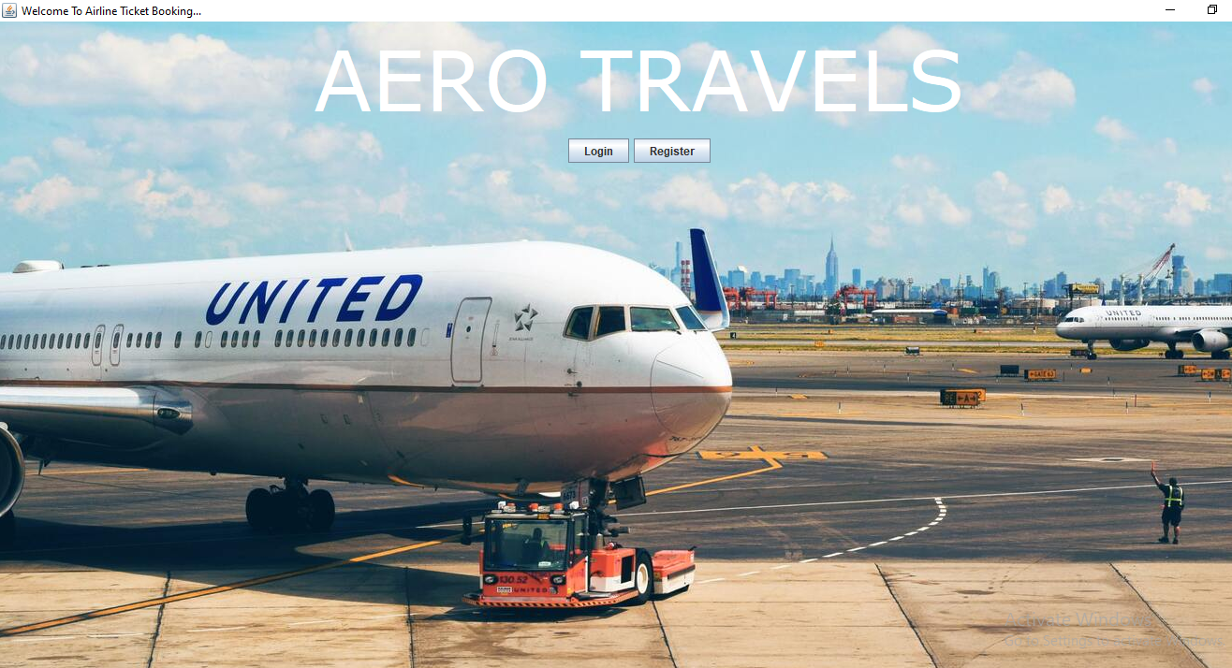

REGISTRATION FORM

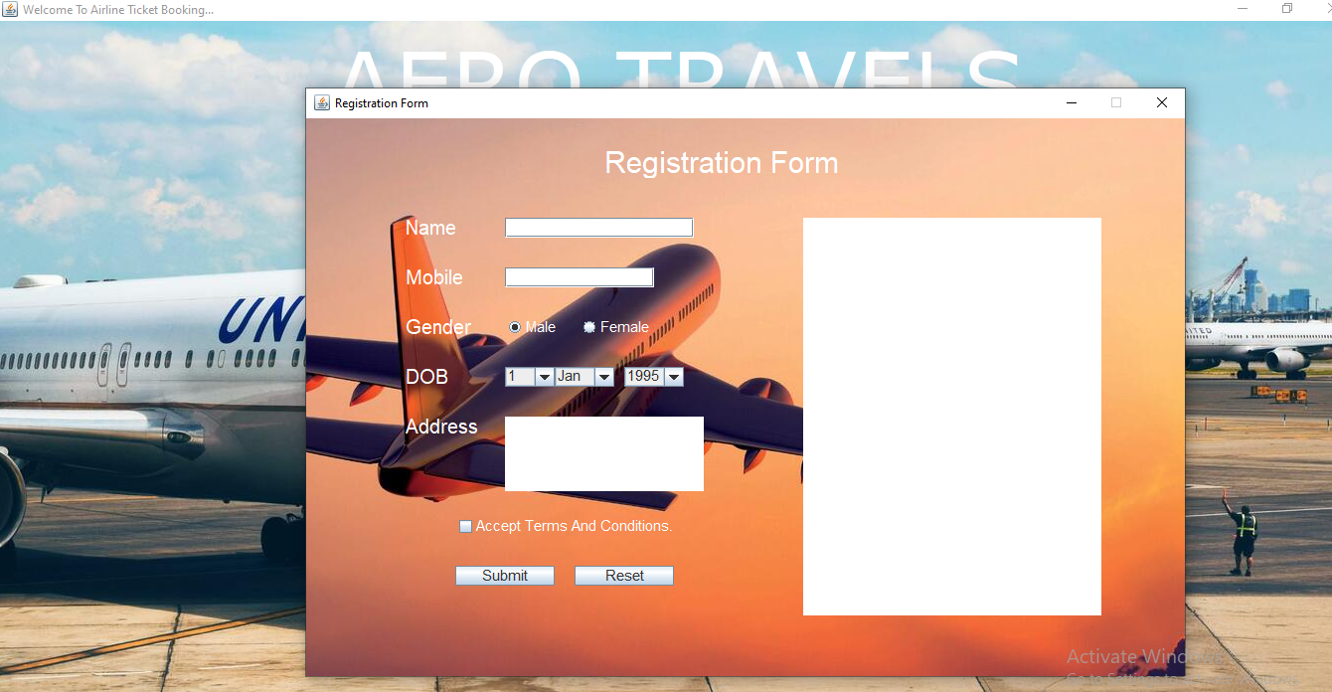

Description: This is registration form for registering with site, registered users will be provided with unique username and password.

LOGIN FORM

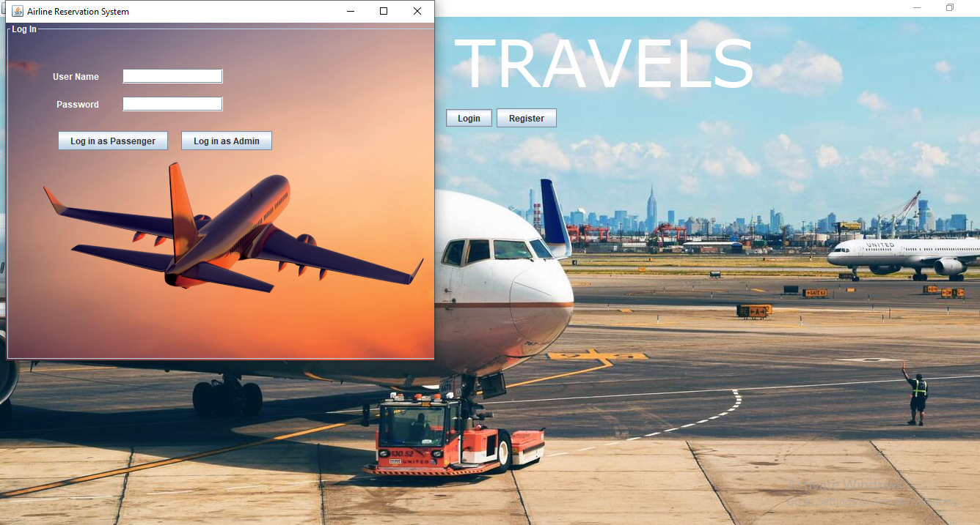

LOGIN AS ADMIN

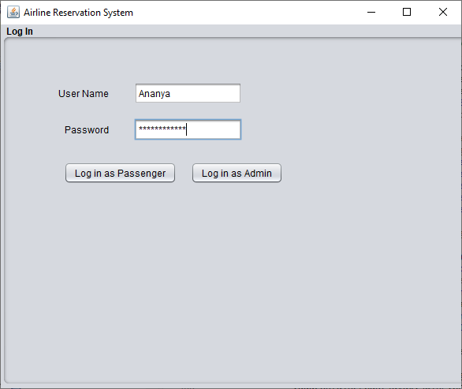

Description: This is login form for user and admin.

FLIGHT SCHEDULES

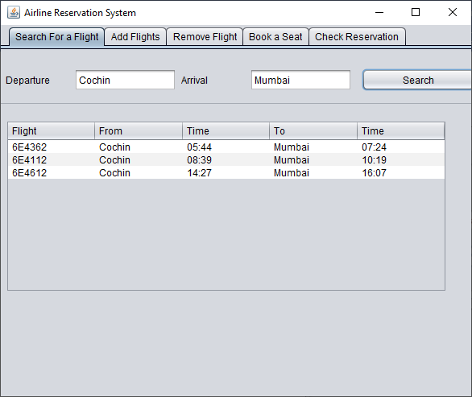

Description: Updating, deleting of flight can be done through this form by admin.

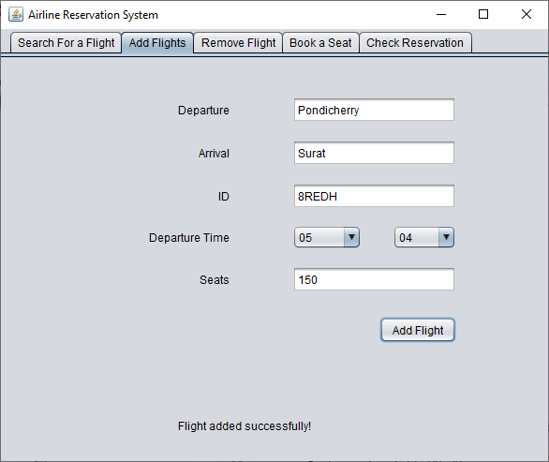

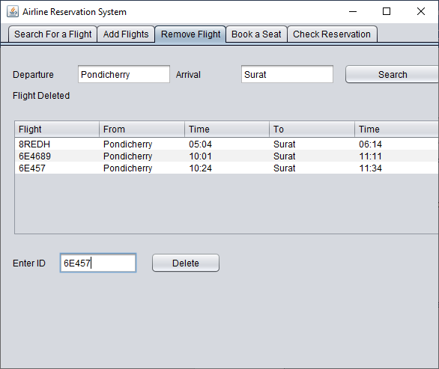

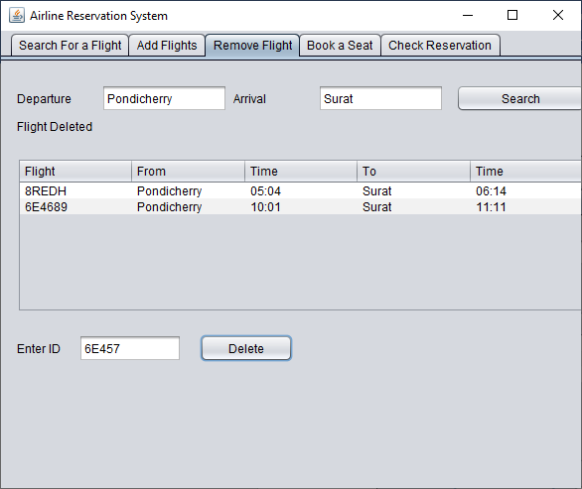

TICKET BOOKING

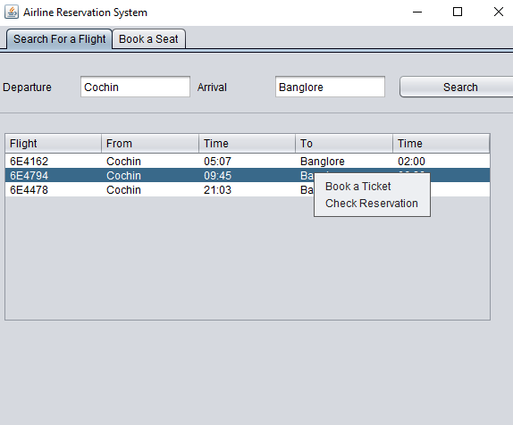

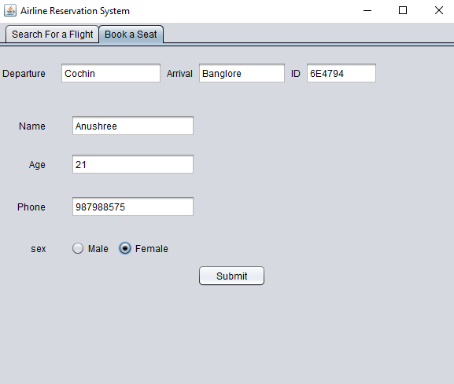

Description: This form is used to book the ticket and it generates the ticket id for user.

CONCLUSION

CONCLUSION
Getting accurate information about what visas or permits you need is an important part of preparing for a trip or stay abroad. To help you with this task we have provided information about embassies and consulates abroad, and we have also included companies that provide visa and passport services.
It reduces the scope of manual error and conveniently maintains any modifications, cancellations in the reservations. It not only provides flight details but also but also creates a platform to book tickets, cancels or modifies ticket timings or dates and even informs about the number of people on board!

BIBILOGRAPHY

BIBILOGRAPHY

References:

SOFTWARE ENGINEERING - By Roger’s.Pressman
NoSQL TUTORIALS
Advanced Software Engineering - Ikvinderpal Singh

Websites:

- www.w3schools.com
- www.tutorialspoint.com
- www.mongodb.com

